UNITED STATES
SECURITIES AND EXCHANGE COMMISSION
Washington, D.C. 20549
FORM 8-K
Current Report Pursuant
to Section 13 or 15(d) of the
Securities Exchange Act of 1934
Date of Report (Date of Earliest Event Reported)
October 1, 2026
World Financial Network Credit Card Master Note Trust
(Exact Name of Issuing Entity as Specified in its Charter)

Commission File Number of Issuing Entity: 333-113669
Central Index Key Number of Issuing Entity: 0001282663
World Financial Network Credit Card Master Trust
(Exact Name of Issuer of Collateral Certificate as Specified in its Charter)

Commission File Number of Issuer of the Collateral Certificate: 333-60418-01
Central Index Key Number of Issuer of the Collateral Certificate: 0001140096

WFN Credit Company, LLC
(Exact Name of Depositor/Registrant as Specified in its Charter)

Commission File Number of Depositor: 333-60418
Central Index Key Number of Depositor: 0001139552
Comenity Capital Bank
(Successor to Comenity Bank)
(Exact Name of Sponsor as Specified in its Charter)

Central Index Key Number of Sponsor: 0002142858

Delaware
(State or Other Jurisdiction of Incorporation of Issuing Entity and Registrant)
31-1772814
(I.R.S. Employer Identification No. of Registrant)
3095 Loyalty Circle, Columbus, Ohio |  |  |  |  |  | 43219
(Address of Principal Executive Offices of Registrant) |  |  |  |  |  | (Zip Code)

(614) 729-5044
(Registrant’s Telephone Number, Including Area Code)
N/A
(Former Name or Former Address, if Changed Since Last Report)
Check the appropriate box below if the Form 8-K filing is intended to simultaneously satisfy the filing obligation of the registrant under any of the following provisions:
[ ] Written communications pursuant to Rule 425 under the Securities Act (17 CFR 230.425)
[ ] Soliciting material pursuant to Rule 14a-12 under the Exchange Act (17 CFR 240.14a-12)
[ ] Pre-commencement communications pursuant to Rule 14d-2(b) under the Exchange Act (17 CFR 240.14d-2(b))
[ ] Pre-commencement communications pursuant to Rule 13e-4(c) under the Exchange Act (17 CFR 240.13e-4(c))

Securities registered pursuant to Section 12(b) of the Securities Exchange Act of 1934:

Title of each class |  |  | Trading Symbol(s) |  |  | Name of each exchange on which registered
N/A |  |  | N/A |  |  | N/A

Indicate by check mark whether the registrant is an emerging growth company as defined in Rule 405 of the Securities Act of 1933 (§230.405 of this chapter) or Rule 12b-2 of the Securities Exchange Act of 1934 (§240.12b-2 of this chapter).

Emerging growth company [ ]

If an emerging growth company, indicate by check mark if the registrant has elected not to use the extended transition period for complying with any new or revised financial accounting standards provided pursuant to Section 13(a) of the Exchange Act. [ ]

Item 1.01. Entry into a Material Definitive Agreement.

On October 1, 2026, Comenity Capital Bank (“CCB”) entered into a Seventh Amended and Restated Service Agreement (the “Seventh Amended and Restated Service Agreement”) with Comenity Servicing LLC (“CSERV”), pursuant to which CSERV provides certain services to CCB. A copy of the Seventh Amended and Restated Service Agreement is filed with this Form 8-K as Exhibit 99.1.

On October 1, 2026, CCB and CSERV entered into the First Amendment (the “First Amendment”) to the Seventh Amended and Restated Service Agreement. A copy of the First Amendment is filed with this Form 8-K as Exhibit 99.2.

Item 6.02. Change of Servicer.

As discussed below under “Item 8.01. Other Events,” upon the merger of Comenity Bank (formerly known as World Financial Network Bank) (“CB”) with and into CCB, with CCB as the surviving entity, CCB assumed all rights, duties and obligations of CB in any capacity relating to the World Financial Network Credit Card Master Trust (the “Master Trust”) and the World Financial Network Credit Card Master Note Trust (the “Note Trust”, together with the Master Trust, the “Trusts”), including responsibility for originating credit card accounts, servicing the credit card receivables held by the Master Trust under the Second Amended and Restated Pooling and Servicing Agreement, dated as of August 1, 2001 (as amended, supplemented and otherwise modified from time to time, the “Pooling and Servicing Agreement”), among WFN Credit Company, LLC, as transferor (“WFN Credit”), CB, as servicer, and U.S. Bank National Association, as trustee (“U.S. Bank”), and servicing the receivables for the benefit of the Note Trust under the Transfer and Servicing Agreement, dated as of August 1, 2001 (as amended, supplemented and otherwise modified from time to time, the “Transfer and Servicing Agreement”), among WFN Credit, as transferor, CB, as servicer, and the Note Trust, as issuer.

CCB is a Utah industrial bank and Federal Deposit Insurance Corporation (the “FDIC”)-insured depository institution, with its headquarters at 12921 South Vista Station Blvd, Suite 100, Draper, UT 84020. CCB is an indirect, wholly-owned subsidiary of Bread Financial Holdings, Inc. (the “Corporation”) and an affiliate of CB. CCB issues co-brand general purpose and private label credit card products for nationally recognized retailers and other brand partners and offers direct-to-consumer credit solutions. Products are offered through CCB’s co-brand and private label credit card programs, direct-to-consumer proprietary general purpose credit cards, pay-over-time products, including both installment loan and “split-pay” offerings through its payment technology solution, Bread Pay, and direct-to-consumer, or retail, deposit products, referred to as Bread Savings, primarily in the form of certificates of deposits and high-yield savings accounts. As of the date of this Report, CCB is regulated and supervised by the Utah Department of Financial Institutions, the FDIC and the Consumer Financial Protection Bureau. CCB has been confirmed to qualify as an Eligible Servicer under each of the Pooling and Servicing Agreement and the Transfer and Servicing Agreement.

CB had been the servicer under the Pooling and Servicing Agreement and the Transfer and Servicing Agreement, and had been servicing the credit card receivables in the Master Trust since January 17, 1996.

Pursuant to the Pooling and Servicing Agreement and the Transfer and Servicing Agreement, the servicer is responsible for servicing and administering the receivables, collecting payments due under the receivables and charging off uncollectible receivables, all in accordance with its customary and usual servicing procedures for servicing credit card receivables comparable to the receivables and in accordance with the credit card guidelines. The servicer is also responsible for establishing and maintaining the collection account and the excess funding account, allocating collections among each series of securities, preparing daily reports and monthly servicer’s certificates for the trustee and the indenture trustee, making filings with the Securities and Exchange Commission (the “SEC”) on behalf of the Trusts, and paying all expenses incurred in connection with the Trusts and servicing activities, including fees and disbursements of the trustee, indenture trustee, owner trustee and administrator.

The servicer’s rights and obligations with respect to servicing the credit card receivables held by the Master Trust are more fully described in the form of prospectus filed with the SEC on April 2, 2025, which is included as part of the Registration Statement on Form SF-3 relating to the notes of the Note Trust (File Nos. 333-286337, 333-286337-01 and 333-286337-02).

Item 8.01. Other Events.

On October 1, 2026, the Corporation completed the merger of its indirect, wholly-owned subsidiary, CB, with and into CCB, an indirect, wholly-owned subsidiary of the Corporation, with CCB as the surviving entity. By virtue of the merger, all property and rights and all of the liabilities and obligations of CB as they existed at the time of the merger became the property and rights and liabilities and obligations of CCB, which also became the successor to CB in each of its capacities in relation to WFN Credit, as depositor, the Master Trust and the Note Trust, including as sponsor, servicer and administrator.

In connection with the merger, succession and related events described above, the Omnibus Securitization Agreements Assignment and Assumption Agreement, among CB, CCB, WFN Credit, the Note Trust, U.S. Bank, and the lead agent and administrative agents party thereto (the “Omnibus Securitization Agreements Assignment and Assumption Agreement”), listed below under “Item 9.01(d). Exhibits” was executed on September 23, 2026, and became effective as of October 1, 2026.

Item 9.01. Financial Statements and Exhibits.

(a) Not applicable.

(b) Not applicable.

(c) Not applicable.

(d) Exhibits.

Exhibit No. |  |  |  |  |  | Document Description
4.1.1 |  |  |  |  |  | Omnibus Securitization Agreements Assignment and Assumption Agreement.
99.1 |  |  |  |  |  | Seventh Amended and Restated Services Agreement.
99.2 |  |  |  |  |  | First Amendment to Seventh Amended and Restated Services Agreement.

SIGNATURES

Pursuant to the requirements of the Securities Exchange Act of 1934, the registrant has duly caused this report to be signed on its behalf by the undersigned hereunto duly authorized.

WFN CREDIT COMPANY, LLC as depositor

By: /s/ Wai Chung
Name: Wai Chung
Title: Treasurer

Dated: October 1, 2026
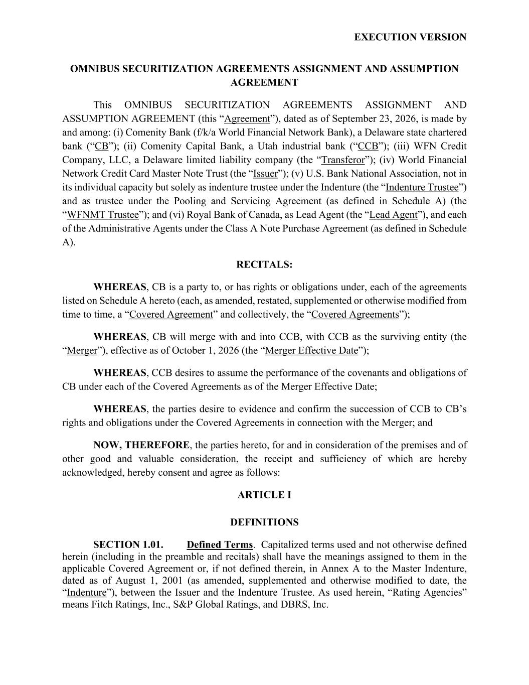

EXECUTION VERSION OMNIBUS SECURITIZATION AGREEMENTS ASSIGNMENT AND ASSUMPTION AGREEMENT This OMNIBUS SECURITIZATION AGREEMENTS ASSIGNMENT AND ASSUMPTION AGREEMENT (this “Agreement”), dated as of September 23, 2026, is made by and among: (i) Comenity Bank (f/k/a World Financial Network Bank), a Delaware state chartered bank (“CB”); (ii) Comenity Capital Bank, a Utah industrial bank (“CCB”); (iii) WFN Credit Company, LLC, a Delaware limited liability company (the “Transferor”); (iv) World Financial Network Credit Card Master Note Trust (the “Issuer”); (v) U.S. Bank National Association, not in its individual capacity but solely as indenture trustee under the Indenture (the “Indenture Trustee”) and as trustee under the Pooling and Servicing Agreement (as defined in Schedule A) (the “WFNMT Trustee”); and (vi) Royal Bank of Canada, as Lead Agent (the “Lead Agent”), and each of the Administrative Agents under the Class A Note Purchase Agreement (as defined in Schedule A). RECITALS: WHEREAS, CB is a party to, or has rights or obligations under, each of the agreements listed on Schedule A hereto (each, as amended, restated, supplemented or otherwise modified from time to time, a “Covered Agreement” and collectively, the “Covered Agreements”); WHEREAS, CB will merge with and into CCB, with CCB as the surviving entity (the “Merger”), effective as of October 1, 2026 (the “Merger Effective Date”); WHEREAS, CCB desires to assume the performance of the covenants and obligations of CB under each of the Covered Agreements as of the Merger Effective Date; WHEREAS, the parties desire to evidence and confirm the succession of CCB to CB’s rights and obligations under the Covered Agreements in connection with the Merger; and NOW, THEREFORE, the parties hereto, for and in consideration of the premises and of other good and valuable consideration, the receipt and sufficiency of which are hereby acknowledged, hereby consent and agree as follows: ARTICLE I DEFINITIONS SECTION 1.01. Defined Terms. Capitalized terms used and not otherwise defined herein (including in the preamble and recitals) shall have the meanings assigned to them in the applicable Covered Agreement or, if not defined therein, in Annex A to the Master Indenture, dated as of August 1, 2001 (as amended, supplemented and otherwise modified to date, the “Indenture”), between the Issuer and the Indenture Trustee. As used herein, “Rating Agencies” means Fitch Ratings, Inc., S&P Global Ratings, and DBRS, Inc.

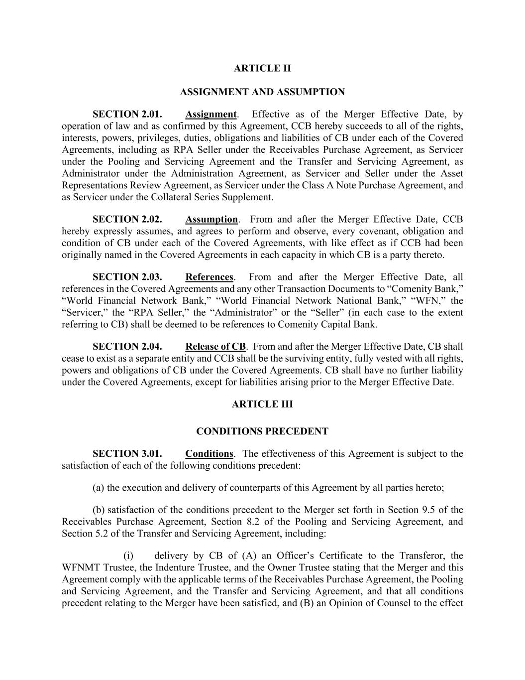
ARTICLE II ASSIGNMENT AND ASSUMPTION SECTION 2.01. Assignment. Effective as of the Merger Effective Date, by operation of law and as confirmed by this Agreement, CCB hereby succeeds to all of the rights, interests, powers, privileges, duties, obligations and liabilities of CB under each of the Covered Agreements, including as RPA Seller under the Receivables Purchase Agreement, as Servicer under the Pooling and Servicing Agreement and the Transfer and Servicing Agreement, as Administrator under the Administration Agreement, as Servicer and Seller under the Asset Representations Review Agreement, as Servicer under the Class A Note Purchase Agreement, and as Servicer under the Collateral Series Supplement. SECTION 2.02. Assumption. From and after the Merger Effective Date, CCB hereby expressly assumes, and agrees to perform and observe, every covenant, obligation and condition of CB under each of the Covered Agreements, with like effect as if CCB had been originally named in the Covered Agreements in each capacity in which CB is a party thereto. SECTION 2.03. References. From and after the Merger Effective Date, all references in the Covered Agreements and any other Transaction Documents to “Comenity Bank,” “World Financial Network Bank,” “World Financial Network National Bank,” “WFN,” the “Servicer,” the “RPA Seller,” the “Administrator” or the “Seller” (in each case to the extent referring to CB) shall be deemed to be references to Comenity Capital Bank. SECTION 2.04. Release of CB. From and after the Merger Effective Date, CB shall cease to exist as a separate entity and CCB shall be the surviving entity, fully vested with all rights, powers and obligations of CB under the Covered Agreements. CB shall have no further liability under the Covered Agreements, except for liabilities arising prior to the Merger Effective Date. ARTICLE III CONDITIONS PRECEDENT SECTION 3.01. Conditions. The effectiveness of this Agreement is subject to the satisfaction of each of the following conditions precedent: (a) the execution and delivery of counterparts of this Agreement by all parties hereto; (b) satisfaction of the conditions precedent to the Merger set forth in Section 9.5 of the Receivables Purchase Agreement, Section 8.2 of the Pooling and Servicing Agreement, and Section 5.2 of the Transfer and Servicing Agreement, including: (i) delivery by CB of (A) an Officer’s Certificate to the Transferor, the WFNMT Trustee, the Indenture Trustee, and the Owner Trustee stating that the Merger and this Agreement comply with the applicable terms of the Receivables Purchase Agreement, the Pooling and Servicing Agreement, and the Transfer and Servicing Agreement, and that all conditions precedent relating to the Merger have been satisfied, and (B) an Opinion of Counsel to the effect

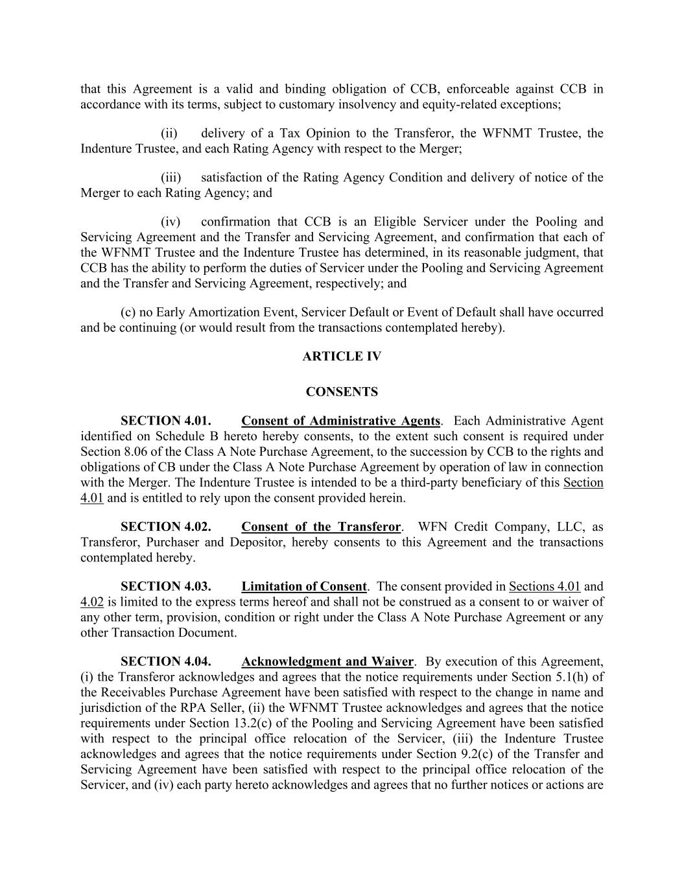
that this Agreement is a valid and binding obligation of CCB, enforceable against CCB in accordance with its terms, subject to customary insolvency and equity-related exceptions; (ii) delivery of a Tax Opinion to the Transferor, the WFNMT Trustee, the Indenture Trustee, and each Rating Agency with respect to the Merger; (iii) satisfaction of the Rating Agency Condition and delivery of notice of the Merger to each Rating Agency; and (iv) confirmation that CCB is an Eligible Servicer under the Pooling and Servicing Agreement and the Transfer and Servicing Agreement, and confirmation that each of the WFNMT Trustee and the Indenture Trustee has determined, in its reasonable judgment, that CCB has the ability to perform the duties of Servicer under the Pooling and Servicing Agreement and the Transfer and Servicing Agreement, respectively; and (c) no Early Amortization Event, Servicer Default or Event of Default shall have occurred and be continuing (or would result from the transactions contemplated hereby). ARTICLE IV CONSENTS SECTION 4.01. Consent of Administrative Agents. Each Administrative Agent identified on Schedule B hereto hereby consents, to the extent such consent is required under Section 8.06 of the Class A Note Purchase Agreement, to the succession by CCB to the rights and obligations of CB under the Class A Note Purchase Agreement by operation of law in connection with the Merger. The Indenture Trustee is intended to be a third-party beneficiary of this Section 4.01 and is entitled to rely upon the consent provided herein. SECTION 4.02. Consent of the Transferor. WFN Credit Company, LLC, as Transferor, Purchaser and Depositor, hereby consents to this Agreement and the transactions contemplated hereby. SECTION 4.03. Limitation of Consent. The consent provided in Sections 4.01 and 4.02 is limited to the express terms hereof and shall not be construed as a consent to or waiver of any other term, provision, condition or right under the Class A Note Purchase Agreement or any other Transaction Document. SECTION 4.04. Acknowledgment and Waiver. By execution of this Agreement, (i) the Transferor acknowledges and agrees that the notice requirements under Section 5.1(h) of the Receivables Purchase Agreement have been satisfied with respect to the change in name and jurisdiction of the RPA Seller, (ii) the WFNMT Trustee acknowledges and agrees that the notice requirements under Section 13.2(c) of the Pooling and Servicing Agreement have been satisfied with respect to the principal office relocation of the Servicer, (iii) the Indenture Trustee acknowledges and agrees that the notice requirements under Section 9.2(c) of the Transfer and Servicing Agreement have been satisfied with respect to the principal office relocation of the Servicer, and (iv) each party hereto acknowledges and agrees that no further notices or actions are

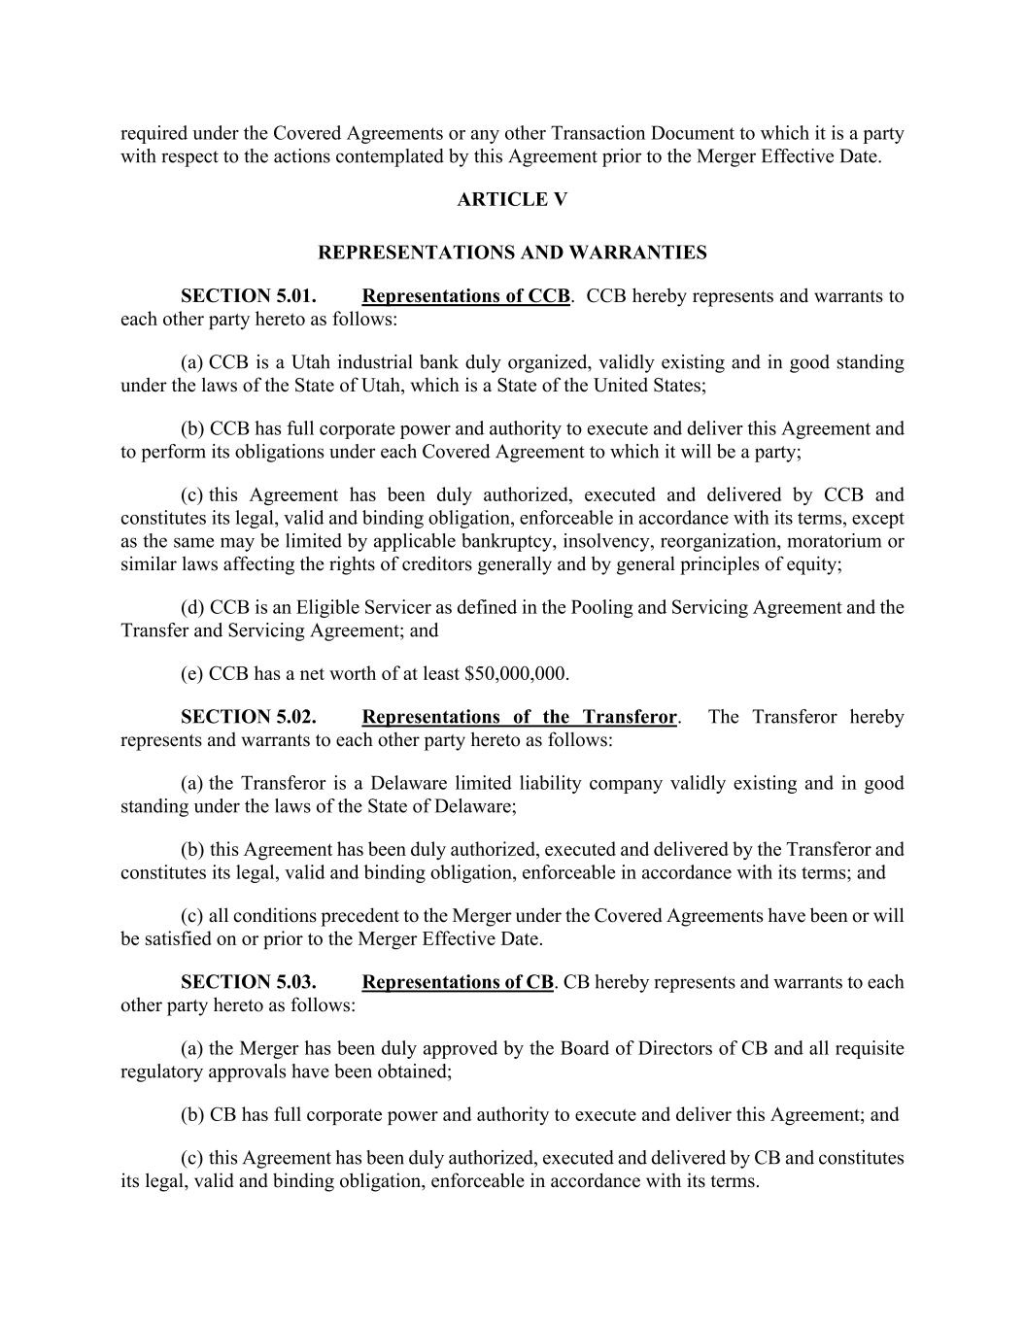
required under the Covered Agreements or any other Transaction Document to which it is a party with respect to the actions contemplated by this Agreement prior to the Merger Effective Date. ARTICLE V REPRESENTATIONS AND WARRANTIES SECTION 5.01. Representations of CCB. CCB hereby represents and warrants to each other party hereto as follows: (a) CCB is a Utah industrial bank duly organized, validly existing and in good standing under the laws of the State of Utah, which is a State of the United States; (b) CCB has full corporate power and authority to execute and deliver this Agreement and to perform its obligations under each Covered Agreement to which it will be a party; (c) this Agreement has been duly authorized, executed and delivered by CCB and constitutes its legal, valid and binding obligation, enforceable in accordance with its terms, except as the same may be limited by applicable bankruptcy, insolvency, reorganization, moratorium or similar laws affecting the rights of creditors generally and by general principles of equity; (d) CCB is an Eligible Servicer as defined in the Pooling and Servicing Agreement and the Transfer and Servicing Agreement; and (e) CCB has a net worth of at least $50,000,000. SECTION 5.02. Representations of the Transferor. The Transferor hereby represents and warrants to each other party hereto as follows: (a) the Transferor is a Delaware limited liability company validly existing and in good standing under the laws of the State of Delaware; (b) this Agreement has been duly authorized, executed and delivered by the Transferor and constitutes its legal, valid and binding obligation, enforceable in accordance with its terms; and (c) all conditions precedent to the Merger under the Covered Agreements have been or will be satisfied on or prior to the Merger Effective Date. SECTION 5.03. Representations of CB. CB hereby represents and warrants to each other party hereto as follows: (a) the Merger has been duly approved by the Board of Directors of CB and all requisite regulatory approvals have been obtained; (b) CB has full corporate power and authority to execute and deliver this Agreement; and (c) this Agreement has been duly authorized, executed and delivered by CB and constitutes its legal, valid and binding obligation, enforceable in accordance with its terms.

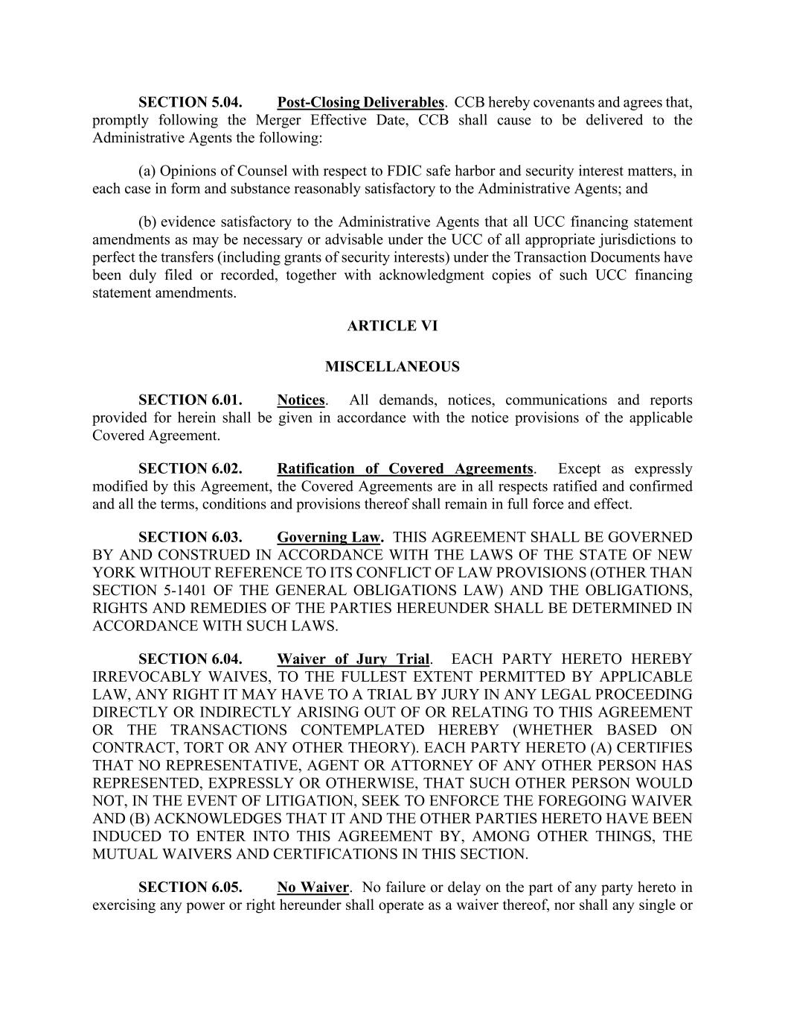
SECTION 5.04. Post-Closing Deliverables. CCB hereby covenants and agrees that, promptly following the Merger Effective Date, CCB shall cause to be delivered to the Administrative Agents the following: (a) Opinions of Counsel with respect to FDIC safe harbor and security interest matters, in each case in form and substance reasonably satisfactory to the Administrative Agents; and (b) evidence satisfactory to the Administrative Agents that all UCC financing statement amendments as may be necessary or advisable under the UCC of all appropriate jurisdictions to perfect the transfers (including grants of security interests) under the Transaction Documents have been duly filed or recorded, together with acknowledgment copies of such UCC financing statement amendments. ARTICLE VI MISCELLANEOUS SECTION 6.01. Notices. All demands, notices, communications and reports provided for herein shall be given in accordance with the notice provisions of the applicable Covered Agreement. SECTION 6.02. Ratification of Covered Agreements. Except as expressly modified by this Agreement, the Covered Agreements are in all respects ratified and confirmed and all the terms, conditions and provisions thereof shall remain in full force and effect. SECTION 6.03. Governing Law. THIS AGREEMENT SHALL BE GOVERNED BY AND CONSTRUED IN ACCORDANCE WITH THE LAWS OF THE STATE OF NEW YORK WITHOUT REFERENCE TO ITS CONFLICT OF LAW PROVISIONS (OTHER THAN SECTION 5-1401 OF THE GENERAL OBLIGATIONS LAW) AND THE OBLIGATIONS, RIGHTS AND REMEDIES OF THE PARTIES HEREUNDER SHALL BE DETERMINED IN ACCORDANCE WITH SUCH LAWS. SECTION 6.04. Waiver of Jury Trial. EACH PARTY HERETO HEREBY IRREVOCABLY WAIVES, TO THE FULLEST EXTENT PERMITTED BY APPLICABLE LAW, ANY RIGHT IT MAY HAVE TO A TRIAL BY JURY IN ANY LEGAL PROCEEDING DIRECTLY OR INDIRECTLY ARISING OUT OF OR RELATING TO THIS AGREEMENT OR THE TRANSACTIONS CONTEMPLATED HEREBY (WHETHER BASED ON CONTRACT, TORT OR ANY OTHER THEORY). EACH PARTY HERETO (A) CERTIFIES THAT NO REPRESENTATIVE, AGENT OR ATTORNEY OF ANY OTHER PERSON HAS REPRESENTED, EXPRESSLY OR OTHERWISE, THAT SUCH OTHER PERSON WOULD NOT, IN THE EVENT OF LITIGATION, SEEK TO ENFORCE THE FOREGOING WAIVER AND (B) ACKNOWLEDGES THAT IT AND THE OTHER PARTIES HERETO HAVE BEEN INDUCED TO ENTER INTO THIS AGREEMENT BY, AMONG OTHER THINGS, THE MUTUAL WAIVERS AND CERTIFICATIONS IN THIS SECTION. SECTION 6.05. No Waiver. No failure or delay on the part of any party hereto in exercising any power or right hereunder shall operate as a waiver thereof, nor shall any single or

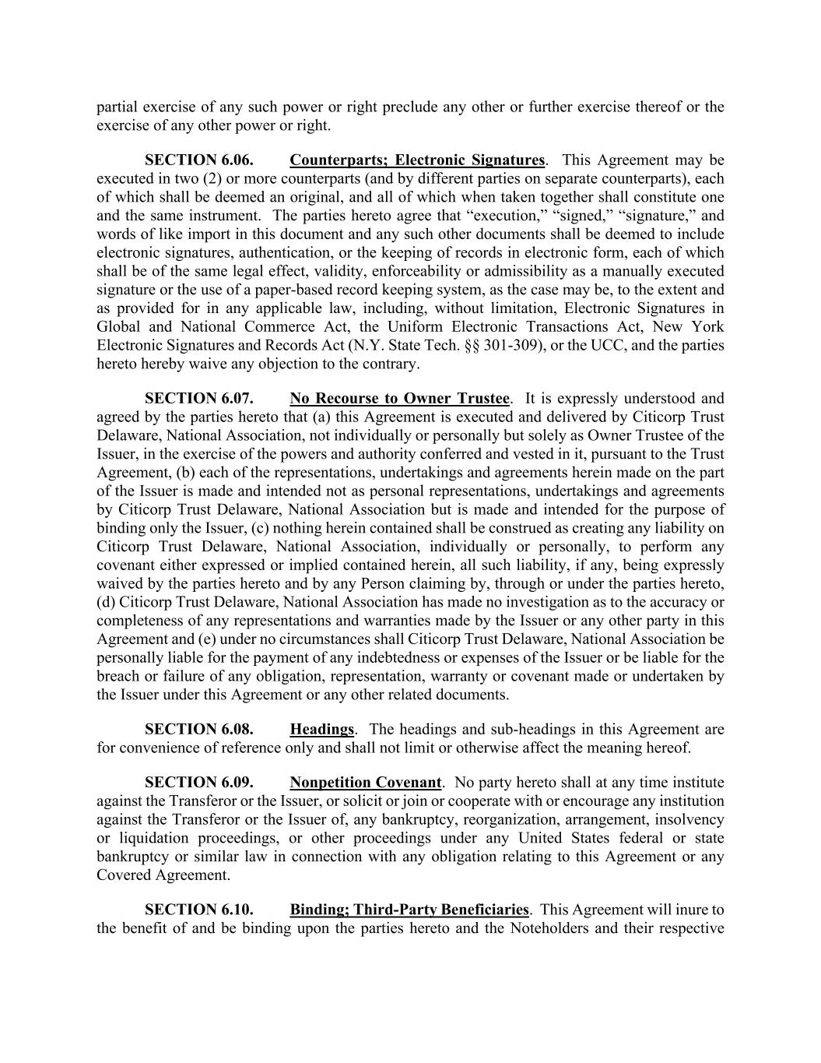
partial exercise of any such power or right preclude any other or further exercise thereof or the exercise of any other power or right. SECTION 6.06. Counterparts; Electronic Signatures. This Agreement may be executed in two (2) or more counterparts (and by different parties on separate counterparts), each of which shall be deemed an original, and all of which when taken together shall constitute one and the same instrument. The parties hereto agree that “execution,” “signed,” “signature,” and words of like import in this document and any such other documents shall be deemed to include electronic signatures, authentication, or the keeping of records in electronic form, each of which shall be of the same legal effect, validity, enforceability or admissibility as a manually executed signature or the use of a paper-based record keeping system, as the case may be, to the extent and as provided for in any applicable law, including, without limitation, Electronic Signatures in Global and National Commerce Act, the Uniform Electronic Transactions Act, New York Electronic Signatures and Records Act (N.Y. State Tech. §§ 301-309), or the UCC, and the parties hereto hereby waive any objection to the contrary. SECTION 6.07. No Recourse to Owner Trustee. It is expressly understood and agreed by the parties hereto that (a) this Agreement is executed and delivered by Citicorp Trust Delaware, National Association, not individually or personally but solely as Owner Trustee of the Issuer, in the exercise of the powers and authority conferred and vested in it, pursuant to the Trust Agreement, (b) each of the representations, undertakings and agreements herein made on the part of the Issuer is made and intended not as personal representations, undertakings and agreements by Citicorp Trust Delaware, National Association but is made and intended for the purpose of binding only the Issuer, (c) nothing herein contained shall be construed as creating any liability on Citicorp Trust Delaware, National Association, individually or personally, to perform any covenant either expressed or implied contained herein, all such liability, if any, being expressly waived by the parties hereto and by any Person claiming by, through or under the parties hereto, (d) Citicorp Trust Delaware, National Association has made no investigation as to the accuracy or completeness of any representations and warranties made by the Issuer or any other party in this Agreement and (e) under no circumstances shall Citicorp Trust Delaware, National Association be personally liable for the payment of any indebtedness or expenses of the Issuer or be liable for the breach or failure of any obligation, representation, warranty or covenant made or undertaken by the Issuer under this Agreement or any other related documents. SECTION 6.08. Headings. The headings and sub-headings in this Agreement are for convenience of reference only and shall not limit or otherwise affect the meaning hereof. SECTION 6.09. Nonpetition Covenant. No party hereto shall at any time institute against the Transferor or the Issuer, or solicit or join or cooperate with or encourage any institution against the Transferor or the Issuer of, any bankruptcy, reorganization, arrangement, insolvency or liquidation proceedings, or other proceedings under any United States federal or state bankruptcy or similar law in connection with any obligation relating to this Agreement or any Covered Agreement. SECTION 6.10. Binding; Third-Party Beneficiaries. This Agreement will inure to the benefit of and be binding upon the parties hereto and the Noteholders and their respective

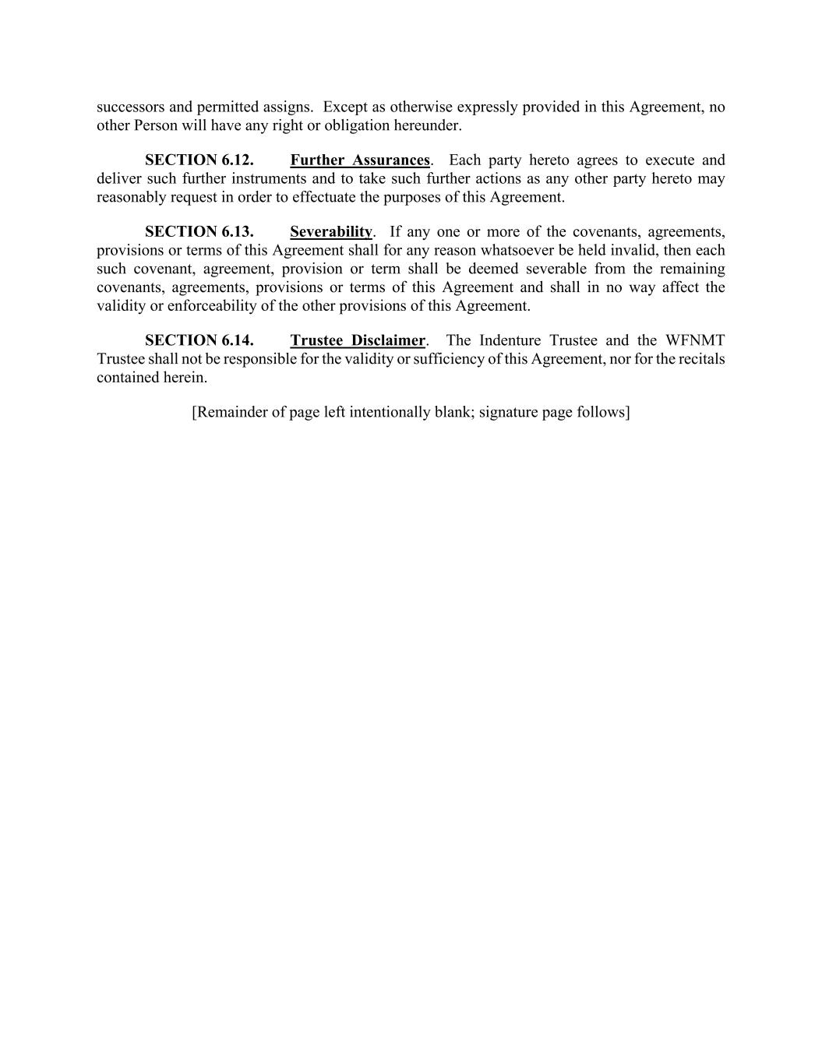
successors and permitted assigns. Except as otherwise expressly provided in this Agreement, no other Person will have any right or obligation hereunder. SECTION 6.12. Further Assurances. Each party hereto agrees to execute and deliver such further instruments and to take such further actions as any other party hereto may reasonably request in order to effectuate the purposes of this Agreement. SECTION 6.13. Severability. If any one or more of the covenants, agreements, provisions or terms of this Agreement shall for any reason whatsoever be held invalid, then each such covenant, agreement, provision or term shall be deemed severable from the remaining covenants, agreements, provisions or terms of this Agreement and shall in no way affect the validity or enforceability of the other provisions of this Agreement. SECTION 6.14. Trustee Disclaimer. The Indenture Trustee and the WFNMT Trustee shall not be responsible for the validity or sufficiency of this Agreement, nor for the recitals contained herein. [Remainder of page left intentionally blank; signature page follows]

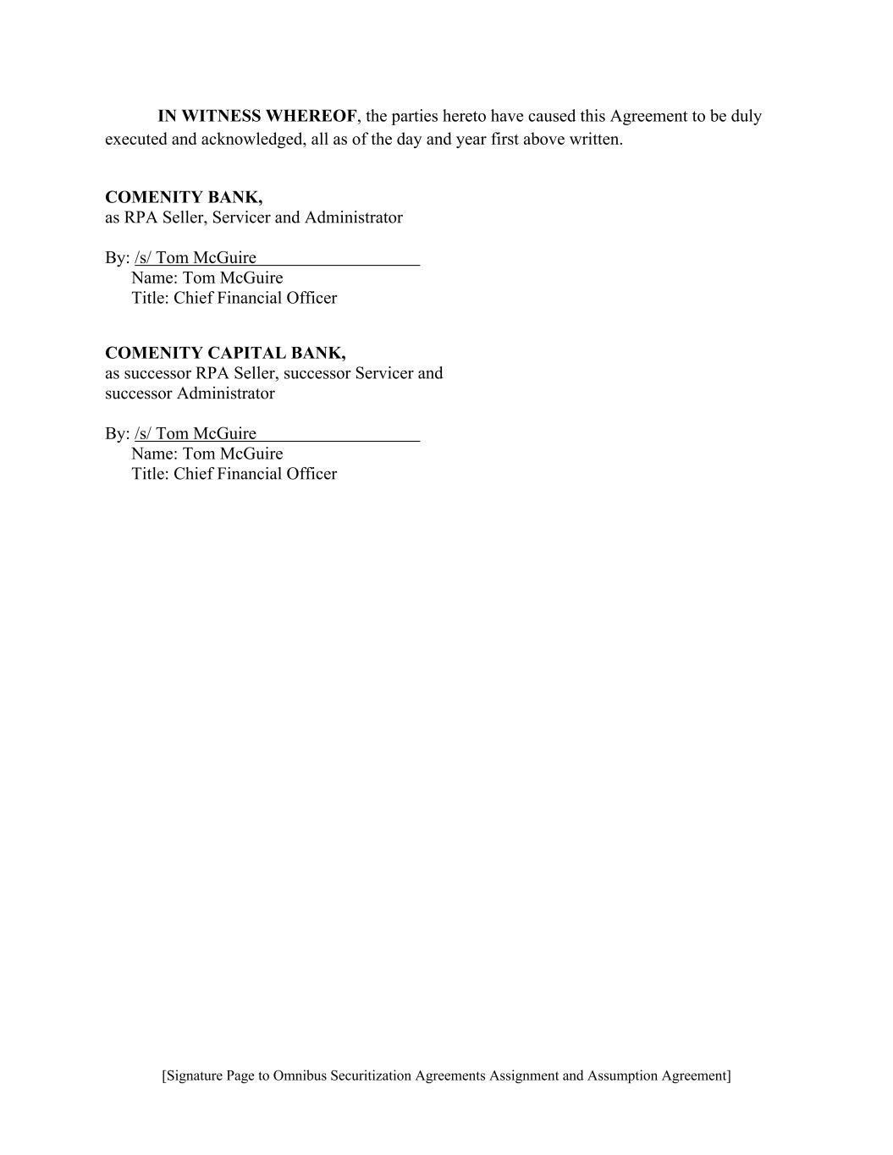
[Signature Page to Omnibus Securitization Agreements Assignment and Assumption Agreement] IN WITNESS WHEREOF, the parties hereto have caused this Agreement to be duly executed and acknowledged, all as of the day and year first above written. COMENITY BANK, as RPA Seller, Servicer and Administrator By: /s/ Tom McGuire Name: Tom McGuire Title: Chief Financial Officer COMENITY CAPITAL BANK, as successor RPA Seller, successor Servicer and successor Administrator By: /s/ Tom McGuire Name: Tom McGuire Title: Chief Financial Officer

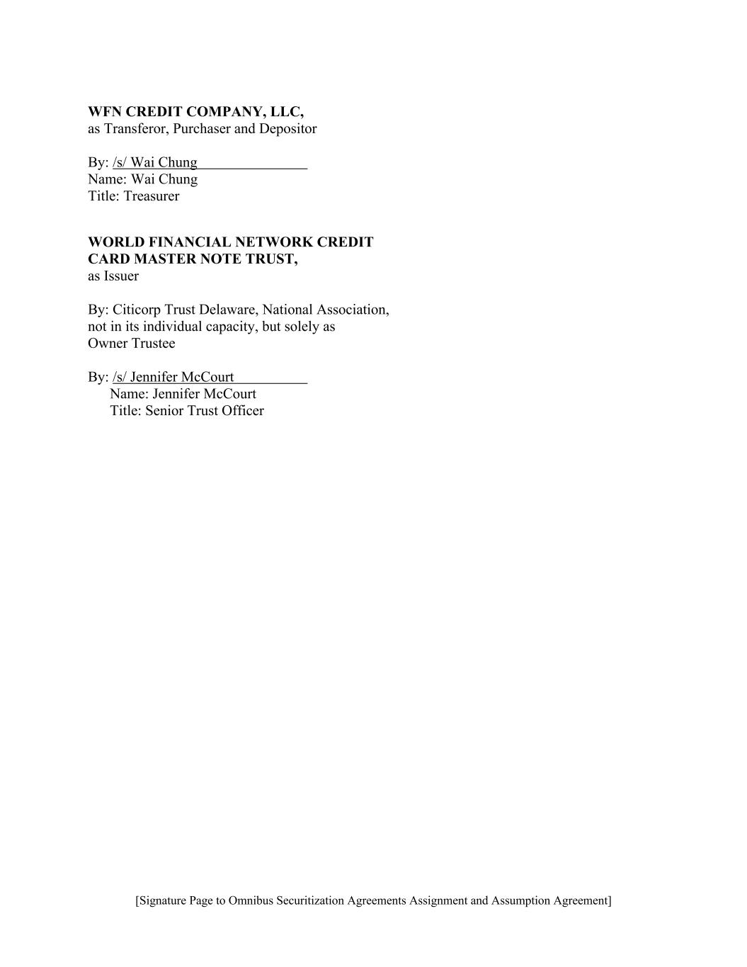
[Signature Page to Omnibus Securitization Agreements Assignment and Assumption Agreement] WFN CREDIT COMPANY, LLC, as Transferor, Purchaser and Depositor By: /s/ Wai Chung Name: Wai Chung Title: Treasurer WORLD FINANCIAL NETWORK CREDIT CARD MASTER NOTE TRUST, as Issuer By: Citicorp Trust Delaware, National Association, not in its individual capacity, but solely as Owner Trustee By: /s/ Jennifer McCourt Name: Jennifer McCourt Title: Senior Trust Officer

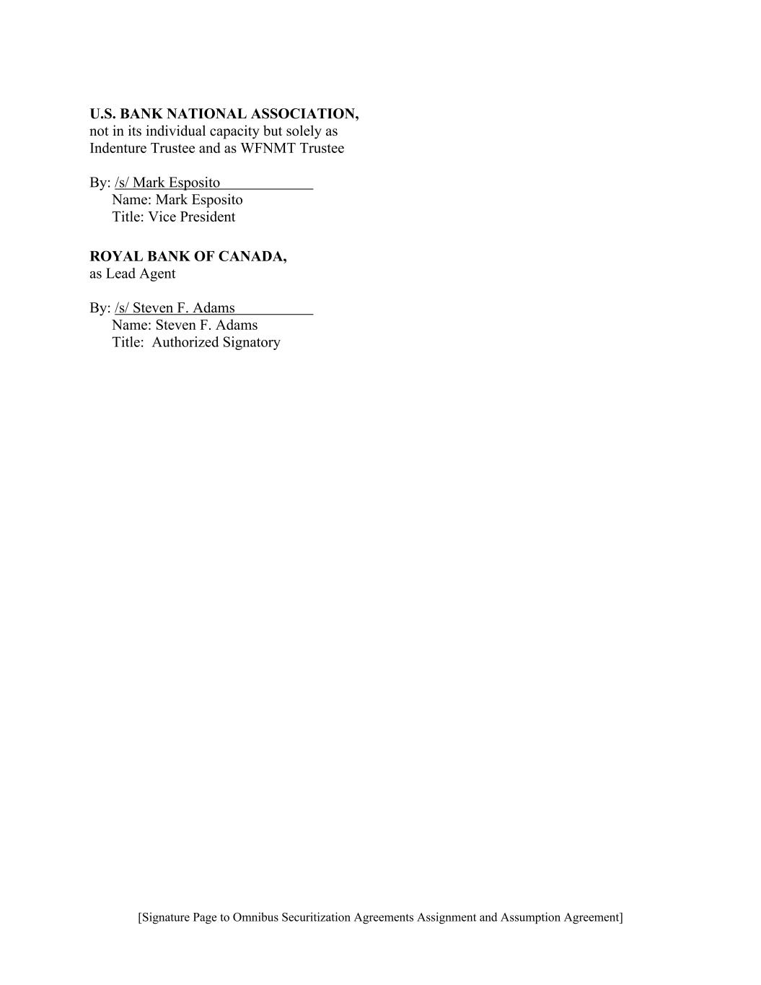
[Signature Page to Omnibus Securitization Agreements Assignment and Assumption Agreement] U.S. BANK NATIONAL ASSOCIATION, not in its individual capacity but solely as Indenture Trustee and as WFNMT Trustee By: /s/ Mark Esposito Name: Mark Esposito Title: Vice President ROYAL BANK OF CANADA, as Lead Agent By: /s/ Steven F. Adams Name: Steven F. Adams Title: Authorized Signatory

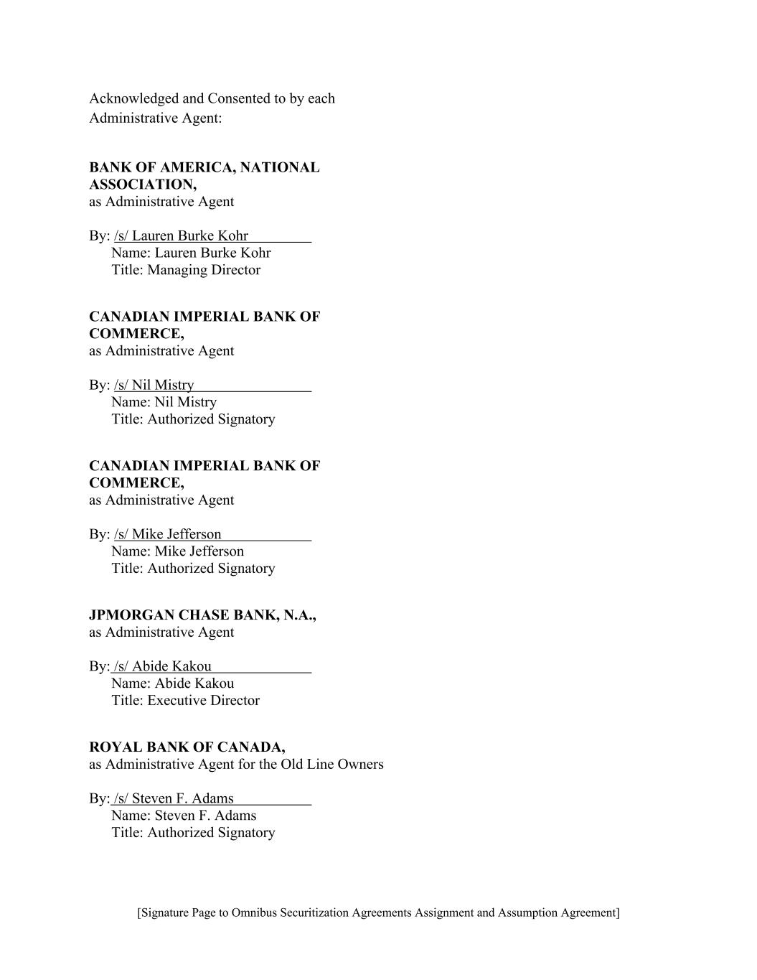
[Signature Page to Omnibus Securitization Agreements Assignment and Assumption Agreement] Acknowledged and Consented to by each Administrative Agent: BANK OF AMERICA, NATIONAL ASSOCIATION, as Administrative Agent By: /s/ Lauren Burke Kohr Name: Lauren Burke Kohr Title: Managing Director CANADIAN IMPERIAL BANK OF COMMERCE, as Administrative Agent By: /s/ Nil Mistry Name: Nil Mistry Title: Authorized Signatory CANADIAN IMPERIAL BANK OF COMMERCE, as Administrative Agent By: /s/ Mike Jefferson Name: Mike Jefferson Title: Authorized Signatory JPMORGAN CHASE BANK, N.A., as Administrative Agent By: /s/ Abide Kakou Name: Abide Kakou Title: Executive Director ROYAL BANK OF CANADA, as Administrative Agent for the Old Line Owners By: /s/ Steven F. Adams Name: Steven F. Adams Title: Authorized Signatory

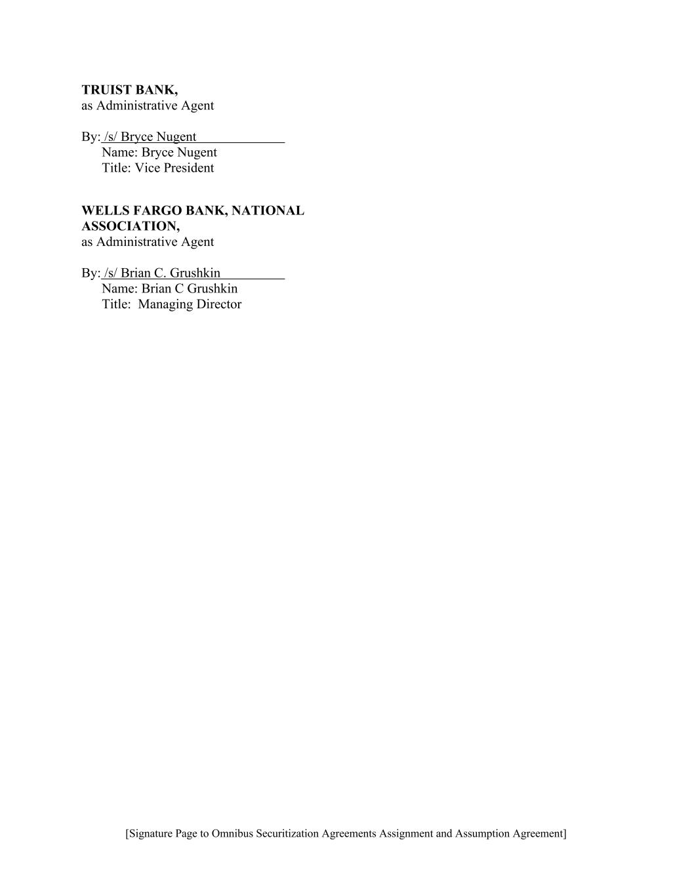
[Signature Page to Omnibus Securitization Agreements Assignment and Assumption Agreement] TRUIST BANK, as Administrative Agent By: /s/ Bryce Nugent Name: Bryce Nugent Title: Vice President WELLS FARGO BANK, NATIONAL ASSOCIATION, as Administrative Agent By: /s/ Brian C. Grushkin Name: Brian C Grushkin Title: Managing Director

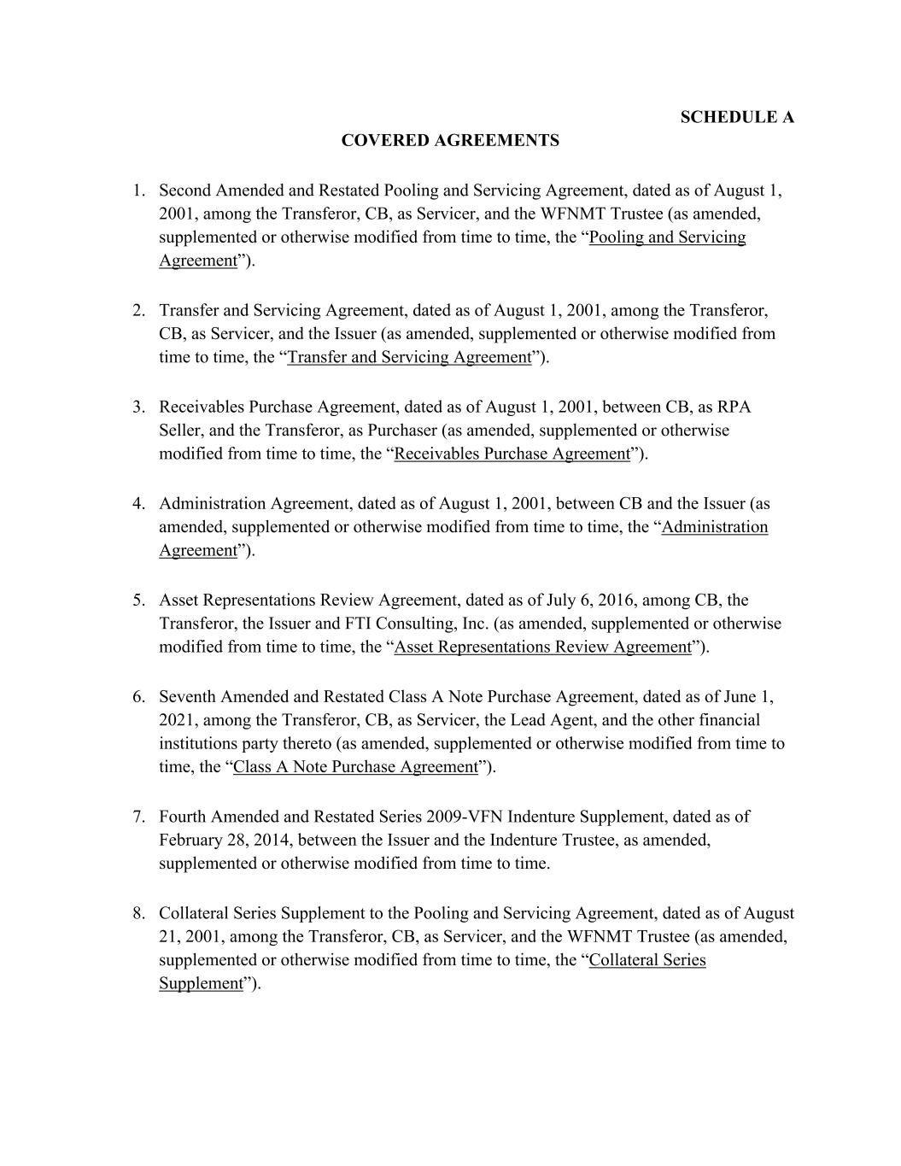
SCHEDULE A COVERED AGREEMENTS 1. Second Amended and Restated Pooling and Servicing Agreement, dated as of August 1, 2001, among the Transferor, CB, as Servicer, and the WFNMT Trustee (as amended, supplemented or otherwise modified from time to time, the “Pooling and Servicing Agreement”). 2. Transfer and Servicing Agreement, dated as of August 1, 2001, among the Transferor, CB, as Servicer, and the Issuer (as amended, supplemented or otherwise modified from time to time, the “Transfer and Servicing Agreement”). 3. Receivables Purchase Agreement, dated as of August 1, 2001, between CB, as RPA Seller, and the Transferor, as Purchaser (as amended, supplemented or otherwise modified from time to time, the “Receivables Purchase Agreement”). 4. Administration Agreement, dated as of August 1, 2001, between CB and the Issuer (as amended, supplemented or otherwise modified from time to time, the “Administration Agreement”). 5. Asset Representations Review Agreement, dated as of July 6, 2016, among CB, the Transferor, the Issuer and FTI Consulting, Inc. (as amended, supplemented or otherwise modified from time to time, the “Asset Representations Review Agreement”). 6. Seventh Amended and Restated Class A Note Purchase Agreement, dated as of June 1, 2021, among the Transferor, CB, as Servicer, the Lead Agent, and the other financial institutions party thereto (as amended, supplemented or otherwise modified from time to time, the “Class A Note Purchase Agreement”). 7. Fourth Amended and Restated Series 2009-VFN Indenture Supplement, dated as of February 28, 2014, between the Issuer and the Indenture Trustee, as amended, supplemented or otherwise modified from time to time. 8. Collateral Series Supplement to the Pooling and Servicing Agreement, dated as of August 21, 2001, among the Transferor, CB, as Servicer, and the WFNMT Trustee (as amended, supplemented or otherwise modified from time to time, the “Collateral Series Supplement”).

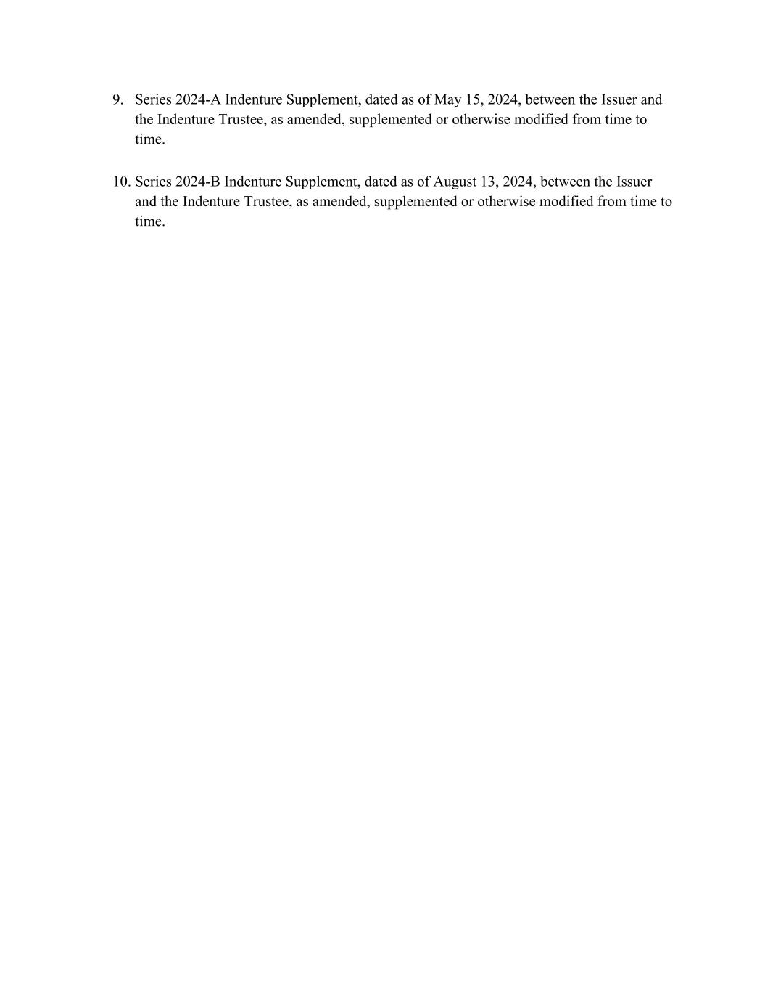
9. Series 2024-A Indenture Supplement, dated as of May 15, 2024, between the Issuer and the Indenture Trustee, as amended, supplemented or otherwise modified from time to time. 10. Series 2024-B Indenture Supplement, dated as of August 13, 2024, between the Issuer and the Indenture Trustee, as amended, supplemented or otherwise modified from time to time.

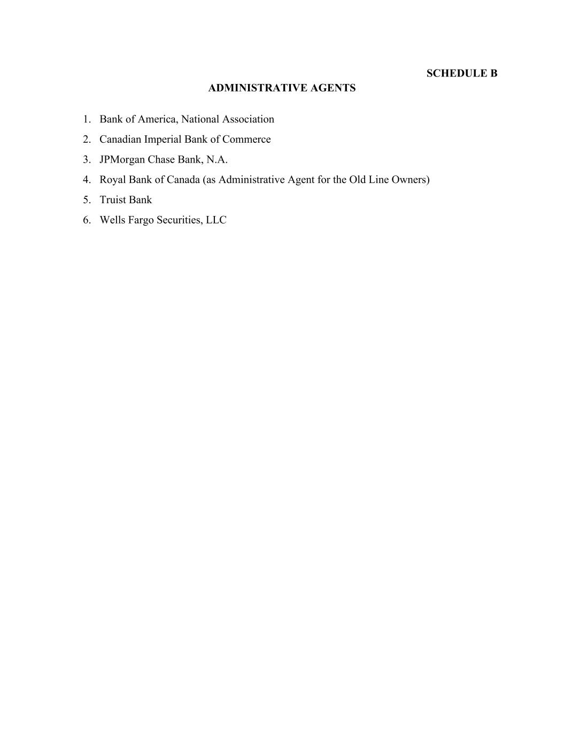
SCHEDULE B ADMINISTRATIVE AGENTS 1. Bank of America, National Association 2. Canadian Imperial Bank of Commerce 3. JPMorgan Chase Bank, N.A. 4. Royal Bank of Canada (as Administrative Agent for the Old Line Owners) 5. Truist Bank 6. Wells Fargo Securities, LLC

SEVENTH AMENDED AND RESTATED SERVICE AGREEMENT

THIS SEVENTH AMENDED AND RESTATED SERVICE AGREEMENT (the “Agreement”) dated as of this 1st day of October, 2026 (the “Effective Date”), is entered into by and between Comenity Servicing LLC (“Servicer”), a Texas limited liability company with its principal place of business at 3095 Loyalty Circle, Columbus, OH 43219 and Comenity Capital Bank (“Bank”), a Utah industrial bank, with its principal place of business at 12921 South Vista Station Boulevard, Suite 100, Draper, UT 84020.

RECITALS

WHEREAS, Bank and Servicer are parties to that certain Sixth Amended and Restated Service Agreement dated as of January 1, 2025, as amended (the “Prior Agreement”) pursuant to which Servicer provides certain services to Bank;

WHEREAS, Bank and Servicer wish to terminate the Prior Agreement and enter into this Agreement which will replace and supersede the Prior Agreement in its entirety; and

WHEREAS, Bank and Servicer are affiliates, and each understands that there are regulatory requirements applicable to any services that an affiliate provides to Bank.

NOW, THEREFORE, in consideration of the mutual agreements hereinafter set forth, and for other good and valuable consideration, the receipt and adequacy of which is hereby acknowledged, Servicer and Bank agree as follows:

ARTICLE 1

SERVICING AND COMPENSATION

Section 1.1 Services and Performance Standards.

(a) Covered Services. Subject to the terms of this Agreement, Servicer, acting as an independent contractor, shall provide to Bank the services as more fully described in Appendix A (collectively, the “Services”). Bank is not obligated to take each of the Services, nor will Servicer have any right to be Bank’s exclusive provider of any such Services. Bank may take and pay for any of such Services at its discretion, or discontinue any Service(s), in whole or in part, and obtain such Service(s) from a third party. If Bank desires to terminate all Services, such termination will be treated as a termination of this Agreement and subject to Section 2.2.

(b) Performance Standards.

1

Seventh Amended and Restated Service Agreement Comenity Servicing LLC / Comenity Capital Bank
Confidential

i.Servicer agrees to perform in accordance with the performance standards set forth in Appendix B (collectively, “Performance Standards”). To the extent that any level of service required by Bank is not enumerated in Appendix B, Servicer agrees to provide at least the same level of service to Bank that Servicer provides to other clients. Servicer and Bank will meet as needed to review the Services and associated Performance Standards and Measuring Periods and determine whether any changes or additions to the Performance Standards and Measuring Periods are needed. Any agreed upon changes will be memorialized in writing and executed by both parties, which writing need not be in the form of a formal amendment to this Agreement but shall be attached to and become a part of Appendix B once executed by the parties. As used herein, “Measuring Period” means the frequency of which a Performance Standard is measured, as set forth in Appendix B.

ii.On or before the 15th calendar day of each month following the end of a Measuring Period, or the following business day if the 15th calendar day is not a business day (the “Performance Report Deadline”), Servicer will provide Bank with a summary of Servicer’s performance regarding each Performance Standard for the just-ended Measuring Period (each such summary with respect to a particular Performance Standard, a “Performance Standard Report”). In addition, Servicer shall provide such other reporting as reasonably requested by Bank from time to time.

iii.In the event that Servicer fails to meet any Performance Standard for any Measuring Period as set forth in the applicable Performance Standard Report, then promptly thereafter Servicer and Bank shall confer to determine the cause of such failure and to develop a plan to improve Servicer’s performance.

(c) Quarterly Review.

i.In addition to Performance Standard Reports, quarterly each Receiver of Service (defined below) for a Service provided hereunder will receive a systemic request to attest to the Receiver of Servicer’s satisfaction with the applicable Service in the previous quarter. Bank’s Affiliate Oversight Committee (the “AOC”) will review all negative attestations for the previous quarter. To the extent the AOC reasonably determines that Servicer’s performance of one or more Services is unsatisfactory, the Receiver of Service and the Provider of Service (defined below) will meet as soon as reasonably practicable and attempt in good faith to agree on a remediation plan with respect to the unsatisfactory performance, which remediation plan shall include an agreed upon timeline for completion. In the event the Receiver of Service and the Provider of Service are unable to agree on a remediation plan after good faith negotiation, or the agreed upon remediation plan is not successfully implemented within the timeframe contemplated, the Receiver of Service and the Provider of Service will refer the issue to their respective
2

Seventh Amended and Restated Service Agreement Comenity Servicing LLC / Comenity Capital Bank
Confidential

senior executives and the dispute resolution procedures set forth in Section 11.3 shall control.

ii.As used herein, “Receiver of Service” means the individual designated by Bank to evaluate the Servicer’s performance of a particular Service and “Provider of Service” means the individual designated by Servicer responsible for providing a particular Service.

(d) Designation of Servicing Representatives. In providing the Services, representatives of Servicer when interacting with customers or other third parties may state that they are speaking “on behalf of Comenity Capital Bank” or “for Comenity Capital Bank” or refer to themselves as “Comenity Servicing” or use other similar designations approved by Bank from time to time but shall not state that they are employees of Comenity Capital Bank.

(e) Nacha Distinction. Capitalized terms in this paragraph not otherwise defined in this Agreement have the meaning defined in the Nacha Operating Rules. It is understood and agreed between the parties that Servicer shall act as Bank’s Third-Party Service Provider and not as a Third-Party Sender. Bank shall at all times maintain agreements with all Originating Depository Financial Institutions that it utilizes for ACH transfers. Servicer shall not provide ACH services to any entity other than Bread Financial Holdings, Inc. and its subsidiary companies, as may be modified from time to time.

Section 1.2 Compensation by Bank for Services; Financial Penalties.

(a)Bank shall pay Servicer for Services provided in accordance with the provisions of Appendix C.

(b)In addition to the fees set forth on Appendix C, if, as reported in the Performance Standard Report for a particular month, Servicer fails to meet one or more Performance Standards in such month, Bank shall receive a service fee credit in an amount calculated as set forth on Appendix D (the “Total Monthly Performance Standard Credit”), and the service fees otherwise payable by Bank in accordance with Appendix C for the month immediately following the month in which the Performance Standard failure occurred (the “Following Month”) shall be reduced by the amount of such Total Monthly Performance Standard Credit. Notwithstanding the foregoing, in no event shall any Total Monthly Performance Standard Credit exceed ten percent (10%) of the total service fees otherwise payable by Bank in the Following Month.

(c)For purposes of calculating the number of Performance Standard failures in a certain Measuring Period, any Performance Standard for which a Performance Standard Report is not provided by Servicer by the fifth (5th) business day
3

Seventh Amended and Restated Service Agreement Comenity Servicing LLC / Comenity Capital Bank
Confidential

following the applicable Performance Report Deadline shall be deemed to have failed in the Measuring Period for which no Performance Standard Report was provided.

Section 1.3 Bank Duties. Insofar as the performance of Services under this Agreement requires data, documents, information or materials required to be furnished by Bank, Bank agrees to furnish the data, documents, information or materials reasonably necessary and within such time as may reasonably be necessary in order for Servicer to perform the Services in a prompt workmanlike manner and within the Performance Standards.

ARTICLE 2

TERM AND TERMINATION

Section 2.1 Term. This Agreement shall become effective as of the Effective Date and shall continue in full force and effect for a period of two (2) years from such date (“Initial Term”), unless terminated in accordance with the terms of this Agreement. This Agreement shall automatically renew for consecutive one (1) year terms (each a “Renewal Term”), unless terminated by either party as specified below.

Section 2.2 Termination. This Agreement will terminate (i) at the option of Servicer, if Bank fails to make any payment when due, and such failure is not cured within thirty (30) calendar days; (ii) at the option of the non-defaulting party, if the other party fails to perform any of its material obligations or duties under this Agreement or commits a material breach of its representations and warranties and such failure to perform or breach is not cured within thirty (30) calendar days after written notice is provided to the defaulting party; (iii) if either party gives at least thirty (30) calendar days prior written notice of termination to the other party; or (iv) subject to Section 11.16, if either party becomes insolvent or generally unable to pay its debts as they become due or shall become the subject of a bankruptcy, conservatorship, receivership or similar proceeding, or shall make a general assignment for the benefit of its creditors, the other party may terminate this Agreement, subject to applicable creditor rights laws. Notwithstanding the above, the parties agree to cooperate for a period of up to three hundred sixty-five (365) days following the termination of this Agreement to ensure orderly transition by Servicer of its duties hereunder to either Bank or Bank’s designated substitute provider of Services. Such transition services shall be provided subject to and in accordance with the terms and conditions of this Agreement. In addition, if Bank determines in its reasonable discretion that 365 days is insufficient to transition the Services to another provider, Servicer shall, at Bank’s request and expense, continue to provide Services hereunder until an orderly transition may be completed, provided the parties agree to such continuation in writing.

Section 2.3 Other Provisions. The terms of this Agreement to the extent necessary to carry out the intentions of the parties underlying their respective rights and obligations shall survive any termination. The parties specifically agree that Section 1.2, Article 4, Article 5, Article 9 and the relevant provisions of this Article 2, and the related obligations of each,
4

Seventh Amended and Restated Service Agreement Comenity Servicing LLC / Comenity Capital Bank
Confidential

including without limitation Bank’s obligation to pay Servicer for Services performed pursuant to Appendix C, shall survive the termination of this Agreement.

Section 2.4 Step-In Right. If Bank’s right to terminate this Agreement arises pursuant to clause (ii) or (iv) of Section 2.2, in addition to Bank’s termination right and regardless of whether Bank exercises such right, the following shall apply:

(a) Servicer shall continue to provide the Services in accordance with the terms of this Agreement, including for the three hundred sixty-five (365) day post-termination transition period referenced in Section 2.2 above.

(b) Servicer shall provide Bank and/or its designees such access to the computer systems (hardware and software) and data used by Servicer to provide the Services hereunder, including general ledger systems, reporting systems, network and information systems, records systems, system backup data, and tax information, as shall be necessary to enable Bank to ensure the continued availability of Services pursuant to this Agreement.

(c) Bank shall have the right, in its sole discretion, to assume managerial oversight of all Service personnel involved in the provision of the Services to Bank for the sole purpose of ensuring the continued availability of Services pursuant to this Agreement.

(d) In the event that Servicer uses a Subcontractor to provide some or all of the Services, to the extent permitted by applicable law and the agreement with such Subcontractor, Bank shall have the right, in its sole discretion, to demand that Servicer assign to Bank Servicer’s rights and associated obligations under such agreement with such Subcontractor and, if exercised, Servicer shall assign and Bank shall assume such rights and obligations.

ARTICLE 3

REPRESENTATIONS AND WARRANTIES

Section 3.1 Performance. Servicer represents and warrants that it has (or has access to) all of the necessary facilities and qualified personnel to provide the Services in accordance with the terms of this Agreement; that it shall perform its obligations hereunder at all times and in all respects in accordance with all applicable federal, state, and local laws and regulations; and that it will perform its obligations hereunder in a timely manner and with due care.

Section 3.2 Organizational Existence. Each party to this Agreement represents and warrants to the other party that it: (i) is duly organized, validly existing, and in good standing under the laws of the jurisdiction of its organization; (ii) is duly qualified and in good standing under the laws of each jurisdiction where its ownership or lease of property or the conduct of its business requires such qualifications; (iii) has the requisite corporate power and authority and the
5

Seventh Amended and Restated Service Agreement Comenity Servicing LLC / Comenity Capital Bank
Confidential

legal right to own, pledge, mortgage, and operate its properties, to lease the properties it operates under lease, and to conduct its business as now conducted and hereafter contemplated to be conducted; (iv) has all necessary licenses, permits, consents, or approvals from or by, and has made all necessary notices to, all authorities having jurisdiction, to the extent required for such current ownership and operation or as proposed to be conducted; and (v) is in compliance with its certificate of incorporation and by-laws.

Section 3.3 Corporate Power. Each party to this Agreement represents and warrants to the other party that the execution, delivery, and performance of this Agreement and all instruments and documents to be delivered hereunder: (i) are within the party’s corporate power; (ii) have been duly authorized by all necessary or proper corporate action; (iii) do not and will not contravene any provisions of the party’s certificate of incorporation or by-laws; (iv) will not violate any law or regulation or any order or decree of any court or governmental instrumentality; and (v) will not conflict with or result in the breach of, or constitute a default under any indenture, mortgage, deed of trust, lease, agreement, or other instrument to which it is a party or by which any of its property is bound. This Agreement has been duly executed and delivered, and constitutes a legal, valid, and binding obligation, enforceable in accordance with its terms, subject to the extent that enforceability may be limited by applicable bankruptcy, reorganization, insolvency, moratorium and other laws affecting creditors’ rights generally from time to time in effect and to the availability of equitable remedies.

Section 3.4 Solvency. Each party to this Agreement represents and warrants to the other party that it is Solvent. “Solvent,” as to an entity for purposes of this Agreement, means (i) such entity is presently able generally to pay its debts as they become due and (ii) such entity does not have unreasonably small capital to carry on such entity’s business as theretofore operated and all business in which such entity is about to or intends to engage.

Section 3.5 No Default. Each party to this Agreement represents and warrants to the other party that it is not in default with respect to any material contract, agreement, lease, or other instrument to which it is a party, nor has it received any notice of default under any such material contract, agreement, lease or other instrument which as a consequence of any such default, would materially and adversely affect the performance of its obligations under this Agreement.

Section 3.6 No Burdensome Restrictions. Each party to this Agreement represents and warrants to the other party that no contract, lease agreement, or other instrument to which it is a party or by which it is bound, and no provision of applicable law or governmental regulation, materially and adversely affects the business, operation, prospects, property, or financial condition of the party such as to impair its ability to meet its obligations under this Agreement.

6

Seventh Amended and Restated Service Agreement Comenity Servicing LLC / Comenity Capital Bank
Confidential

Section 3.7 Information Correct. Each party to this Agreement represents and warrants to the other party that all information furnished for purposes of or in connection with this Agreement or any information hereafter furnished, is to the best of such parties’ knowledge, true and correct in all material respects and no such information omits to state a material fact necessary to make the information so furnished not misleading. There is no fact known which has not been disclosed and which materially and adversely affects the financial condition, business, property, or prospects of the party.

Section 3.8 No Termination Event. Each party to this Agreement represents and warrants to the other party that no event which, with notice or the passage of time or both, would permit termination of this Agreement has occurred and is continuing or, to the best knowledge of the party, is threatened to occur.

ARTICLE 4

CONFIDENTIALITY

Section 4.1 Duty of Confidentiality. In connection with the performance of this Agreement, each party may receive information which the other party (the “Furnishing Party”) has identified to the party receiving such information (the “Receiving Party”) as being confidential or proprietary to the Furnishing Party, or otherwise not generally available to the public (collectively, the “Confidential Information”). Confidential Information includes, but is not limited to, the confidential and proprietary information of either party or its affiliates, subsidiaries, or parent companies disclosed by either party to the other party, either directly or indirectly, in writing, orally or by inspection of tangible objects (including, without limitation, documents, prototypes, samples, plant and equipment). Confidential Information includes, by way of example, but without limitation, the Business Information, Technical Information, Personal Information, and Confidential Supervisory Information described below.

(a)Examples of “Business Information” are: business models, know-how, designs, reports, data, research, financial information, pricing information, corporate client information, market definitions and information, and business inventions and ideas.

(b)Examples of “Technical Information” are: software, algorithms, developments, inventions, processes, ideas, designs, drawings, engineering, hardware configuration, and technical specifications, including, but not limited to, computer terminal specifications, the source code developed from such specifications, all derivative and reverse-engineered works of the specifications, and the documentation and software related to the source code, the specifications and the derivative works.

(c)Examples of “Personal Information” are: all non-public personal information of or related to individual customers or consumers of either party, including but not
7

Seventh Amended and Restated Service Agreement Comenity Servicing LLC / Comenity Capital Bank
Confidential

limited to names, addresses, telephone numbers, account numbers, customer lists, and account, financial or transaction information.

(d)Examples of “Confidential Supervisory Information” are: all information prepared for or received from Bank’s regulators and any other information identified by Bank, as Supervisory Information in accordance with the laws and regulations applicable to Bank.

Each party agrees (i) to keep the Confidential Information confidential, (ii) not to retain, use or disclose the Confidential Information for any purpose, other than the purpose for which it was disclosed and for providing or receiving the Services described in Appendix A, without the prior written consent of the Furnishing Party, (iii) to comply with the California Privacy Rights Act and any subsequent state or federal privacy law applicable to a party; and (iv) to permit the Furnishing Party to audit compliance with this Section 4.1 no less than annually. In the event that a party becomes aware that it can no longer adhere to the provisions of this Section 4.1, it shall notify the other party as soon as possible. In that event, or in the event that a party becomes aware that the other party is not complying with this Section 4.1, the compliant party may take reasonable and appropriate steps to remediate the noncompliant party’s unauthorized use of Personal Information.

Section 4.2 Information which is not Confidential Information. For purposes of this Agreement, “Confidential Information,” with the exclusion of Personal Information, shall not include: (i) information in the public domain at the time that it was provided by the Furnishing Party or subsequently came into the public domain other than as a result of breach of the confidentiality provisions contained herein; (ii) information obtained from a third party (provided such party was not bound by confidentiality agreements with the Furnishing Party); (iii) information released by the Furnishing Party to anyone without restriction; (iv) information that was known to the Receiving Party prior to its disclosure without any obligation to keep it confidential as evidenced by tangible records kept by the Receiving Party in the ordinary course of business; or (v) information independently developed by the Receiving Party.

Section 4.3 Preservation of Confidential Information; Procedures to Protect; Security Controls. The Receiving Party shall disclose Confidential Information only to those of its employees who have a need to know in order to accomplish the purposes of this Agreement. Each party shall use its best efforts to ensure that its employees take such action as shall be necessary or advisable to preserve and protect the confidentiality of Confidential Information. In addition, the Receiving Party shall establish commercially reasonable controls to ensure the confidentiality of Confidential Information and to ensure that Confidential Information is not disclosed contrary to the provisions of this Agreement, the Gramm-Leach-Bliley Act, or any other applicable laws. Without limiting the foregoing, each party shall implement such physical and other security measures as are necessary to (i) ensure the security and confidentiality of Confidential Information, (ii) protect against threats or hazards to the security and integrity of Confidential Information, and (iii) protect against unauthorized access to or use of Confidential Information. The Receiving Party shall disclose Confidential Information only to those of its employees who have a need to know in order to accomplish the purposes of this Agreement.
8

Seventh Amended and Restated Service Agreement Comenity Servicing LLC / Comenity Capital Bank
Confidential

Each party shall use its commercially reasonable efforts to ensure that its employees take such action as shall be necessary or advisable to preserve and protect the confidentiality of Confidential Information. The parties shall, at a minimum, establish and maintain such data security program as is necessary to meet the objectives of the Interagency Guidelines Establishing Standards for Safeguarding Customer Information, as such guidelines may be updated from time to time. Servicer shall immediately notify Bank, but in no event later than 48 hours, in the event it believes, or has reason to believe, that a security breach or any other unauthorized intrusion has occurred. Servicer shall respond and take corrective action in accordance with the Global Information Security and Cybersecurity Policy of Bread Financial Holdings, Inc. and its wholly-owned subsidiaries, as such Global Information Security and Cybersecurity Policy may be amended or modified from time to time.

Section 4.4 Return of Confidential Information. The Receiving Party shall, at the Furnishing Party’s option, either destroy or return the Confidential Information to the Furnishing Party as soon as possible after completion of the Services or other circumstances for which such Confidential Information was disclosed. Upon written request or upon termination of this Agreement, the Receiving Party shall, at its option, either destroy or return to the Furnishing Party such Confidential Information in its possession or control. Notwithstanding the foregoing, the Receiving Party may retain Confidential Information to the extent needed to comply with applicable law or such Receiving Party’s record or document retention or similar policy.

Section 4.5 Compelled Disclosure. If the Receiving Party is legally compelled (including, without limitation, by law, rule, regulation, stock exchange or governmental regulating or administrative or similar agency, as part of a judicial or administrative proceeding or otherwise, by deposition, interrogatory, request for information or documents, subpoena, civil or criminal investigative demand or otherwise) to disclose any Confidential Information, the Receiving Party shall promptly notify, where allowed by law to do so, the Furnishing Party to permit the Furnishing Party to seek a protective order or take other appropriate action. The Receiving Party shall also cooperate in the Furnishing Party’s efforts to obtain a protective order or other reasonable assurance that the Confidential Information shall be treated confidentially. If, in the absence of a protective order, the Receiving Party or its representatives are, in the opinion of counsel, compelled as a matter of law to disclose the Confidential Information, the Receiving Party may disclose to the party compelling disclosure only the part of the Confidential Information as is required by law to be disclosed (in which case, prior to disclosure, the Receiving Party shall advise and consult with the Furnishing Party and its counsel as to such disclosure and the nature and wording of such disclosure) and shall use its reasonable best efforts to obtain confidential treatment therefor.

Section 4.6 Continuing Duty. Each party’s obligations to confidentiality and non-disclosure shall survive the termination of this Agreement.

9

Seventh Amended and Restated Service Agreement Comenity Servicing LLC / Comenity Capital Bank
Confidential

ARTICLE 5

INDEMNIFICATION

Section 5.1 Servicer shall indemnify and hold Bank, its officers, directors, employees and agents harmless from and against any “Losses,” defined in Section 5.4 below, arising out of or in connection with:

(a) The intentional or negligent act or omission of Servicer or of its officers, directors, employees, or agents (including Subcontractors) in the performance of the duties and obligations of Servicer under this Agreement;

(b) The failure by Servicer, after notice of breach and opportunity to cure in accordance with Section 2.2 above, to comply with the terms of this Agreement;

(c) The failure by Servicer to comply with its obligations under any and all laws, rules, regulations, interpretations, or directives applicable to Servicer; provided, however, that no indemnification shall be available under this clause 5.1 (c) as to any matter for which Bank is required to indemnify Servicer under Section 5.2(d);

(d) The failure by Servicer to comply with all laws, rules, regulations, interpretations, or directives applicable to Bank in its performance of Services on Bank's behalf or to comply with Bank's instructions on compliance in connection with such Services, to the extent permitted by applicable law; or

(e) Any act or omission by Bank, its officers, directors, employees or agents at the request of, and in accordance with such instructions or procedures as may be provided by Servicer, if such act or omission constitutes a failure to comply with any law, rule or regulation applicable to Servicer;

provided, however, that except as specifically provided in clause 5.1 (e) above, Servicer shall not be required to indemnify or hold Bank, its officers, directors, employees or agents harmless from and against any losses arising from any act or omission of Bank, its officers, directors, employees or agents.

Section 5.2 Bank shall indemnify and hold Servicer, its officers, directors, employees and agents harmless from and against any “Losses,” as defined in Section 5.4 below, arising out of or in connection with:

(a) The intentional or negligent act or omission of Bank or of its officers, directors, employees, or agents in the performance of the duties and obligations of Bank under this Agreement;

(b) The failure by Bank, after notice of breach and opportunity to cure in accordance with Section 2.2 above, to comply with the terms of this Agreement;
10

Seventh Amended and Restated Service Agreement Comenity Servicing LLC / Comenity Capital Bank
Confidential

(c) The failure by Bank to comply with its obligations under any and all laws, rules or regulations applicable to Bank; provided, however, that no indemnification shall be available under this clause 5.2 (c) as to matters for which Servicer is required to indemnify Bank under Section 5.1(d); or

(d) Any act or omission by Servicer, its officers, directors, employees or agents, at the request of, and in accordance with such instructions or procedures as may be provided by Bank, if such act or omission constitutes a failure to comply with any law, rule or regulation applicable to Bank;

provided, however, that except as specifically provided in clause 5.2 (d) above, Bank shall not be required to indemnify or hold Servicer, its officers, directors, employees or agents harmless from and against any losses arising from any act or omission of Servicer, its officers, directors, employees or agents.

Section 5.3 Notice of Claims. Each party shall promptly notify the other party of any claim, demand, suit, or threat of suit of which that party becomes aware (except with respect to a threat of suit either party might institute against the other) which may give rise to a right of indemnification pursuant to this Agreement. The indemnifying party will be entitled to participate in the settlement or defense thereof and, if the indemnifying party elects, to take over and control the settlement or defense thereof with counsel satisfactory to the indemnified party. In any case, the indemnifying party and the indemnified party shall cooperate (at no cost to the indemnified party) in the settlement or defense of any such claim, demand, suit, or proceeding.

Section 5.4 Losses. For purposes of this Article 5, the term “Losses” shall mean any losses, damages, costs, and expenses, liabilities, settlements, or similar items including, without limitation, reasonable attorneys’ fees and court costs reasonably incurred by Servicer or Bank, as the case may be.

ARTICLE 6

BANK DATA AND INTELLECTUAL PROPERTY

Section 6.1 Data and Intellectual Property Ownership. The parties acknowledge and agree that, as between Bank and Servicer, any and all data or information provided to Servicer in order for Servicer to provide the Services under the terms of this Agreement is owned (or otherwise licensed or controlled) by Bank (“Bank Data”). Servicer represents and warrants that, unless otherwise agreed upon in writing, Servicer shall use Bank Data solely for the purposes of fulfilling its obligations under the terms of this Agreement and for no other purpose. Furthermore, in the event Bank provides any software, hardware or processes to Servicer, such software, hardware or processes will remain the exclusive property of Bank. Except as provided herein, nothing in this Agreement shall be deemed to convey a proprietary interest to Servicer or any third party in any Bank Data, software, hardware, or intellectual property owned or licensed by Bank or any of its non-Servicer affiliates.
11

Seventh Amended and Restated Service Agreement Comenity Servicing LLC / Comenity Capital Bank
Confidential

Section 6.2 Intellectual Property Rights.

(a)Bank Ownership Rights. Subject to Section 6.2(b), if in the course of performing Services for Bank, Servicer provides or creates deliverables or other work product (“Works”) all intellectual property rights associated with such Works shall accrue to Bank. All copyrightable Works created by Servicer in connection with the performance of Services for Bank shall be deemed to be works made for hire for purposes of vesting in Bank all copyrights in such Works.

(b)License. To the extent that the Works contain any material developed by Servicer prior to the performance of Services for Bank, Servicer hereby grants to Bank a perpetual, royalty-free, worldwide license to (a) use, execute, reproduce, display, perform, distribute copies of, modify and prepare derivative works based on such material and (b) make, use and sell products and services under such rights.

(c)Further Action. At Bank’s request, Servicer shall promptly execute any and all documents with the United States Copyright Office, U.S. Patent and Trademark Office and other appropriate U.S. and foreign agencies, and take such other action, at Bank’s expense, to effectuate Bank’s proprietary rights to Works.

Section 6.3 Representation and Warranty by Servicer Regarding Intellectual Property. Servicer represents, to the best of Servicer’s knowledge, that the provision of the Services and the Works created thereby do not violate the intellectual property rights of any third party.
Section 6.4 Intellectual Property Indemnity. Notwithstanding the provisions of Article 9 of this Agreement, Servicer agrees to indemnify, defend, protect, save and hold harmless Bank, Bank’s subsidiaries and affiliates, and their respective directors, officers, employees and agents, against any and all losses, liabilities, judgments, awards and costs (including legal fees and out-of-pocket expenses reasonably incurred) arising out of or related to any claim in whole or in part that Bank’s use of the Services or Works, or other goods and services provided to Bank by Servicer pursuant to this Agreement infringes, misappropriates, or otherwise violates any third parties’ intellectual property rights. Servicer shall defend and settle at its sole expense all suits or proceedings arising in whole or in part out of the foregoing, provided that Bank gives Servicer reasonably prompt notice of any such claim. Servicer’s obligation of indemnification shall survive even if Bank does not provide Servicer with reasonably prompt notice of any such claim of which Bank learns so long as such failure does not materially prejudice Servicer. If, as a result of any such claim, Bank is enjoined from use of the Services or Works, or if Servicer believes that Bank is likely to become the subject of a claim, Servicer, at its option and expense shall (i) procure the right for Bank to continue to use the Services or Works; or (ii) modify the Services or Works so that they are not infringing, while remaining functionally equivalent to the current Services or Works. If Servicer must discontinue Services or Works (or Bank’s use thereof) because of such a claim, Bank may terminate this Agreement or equitably reduce the fees paid or payable to Servicer associated with the affected Service or Work.

12

Seventh Amended and Restated Service Agreement Comenity Servicing LLC / Comenity Capital Bank
Confidential

ARTICLE 7

SUBCONTRACTING

Section 7.1 Subcontractors.

(a)Subject to the restrictions set forth below, in performing its obligations under this Agreement, Servicer may engage subcontractors and other third parties (collectively, “Subcontractors”), provided that Servicer shall not outsource any Services pursuant to engagements classified as “Tier 1” or “Enhanced Tier 2” without Bank’s approval. “Tier 1” and “Enhanced Tier 2” have the meanings given to such terms in the Supplier Risk Management Policy of Bread Financial Holdings, Inc. and its wholly-owned subsidiaries (the “Supplier Risk Management Policy), as it may be amended from time to time.

(b)Servicer’s use of Subcontractors shall at all times be subject to the following requirements:

i.Servicer’s engagement of Subcontractors shall be in compliance with (i) applicable Bank policies, including, but not limited to, the Supplier Risk Management Policy, including all monitoring and reporting obligations set forth therein, and (ii) applicable law, which includes for purposes of any such engagement formal or informal direction from Bank’s regulators;

ii.Any Subcontractor engaged by Servicer to provide Services hereunder shall be an independent, unrelated third party of Servicer; provided, however, that notwithstanding the foregoing, Servicer may engage Bread Financial Global Solutions India LLP (“BFGSI”) as a Subcontractor, and all other requirements of this Section 7.1 shall apply to any such engagement of BFGSI;

iii.Any agreement between Servicer and a Subcontractor regarding Services provided by Servicer to Bank hereunder shall be on terms, in the aggregate, that are equal to or better than the prevailing market standards at the time such agreement is entered into;

iv.All Subcontractors shall, as a condition to their engagement, agree to be bound by provisions substantially similar to those included in this Agreement, specifically those relating to Confidential Information and Bank’s and its regulators’ rights to audit as appropriate, taking into consideration the applicable scope of services provided by such Subcontractor;

v.Servicer shall at all times be responsible for the performance of any Subcontractor and shall remain responsible for the fulfillment of its
13

Seventh Amended and Restated Service Agreement Comenity Servicing LLC / Comenity Capital Bank
Confidential

obligations under this Agreement even after such obligations are subcontracted to a Subcontractor, and

vi.Servicer shall provide periodic reporting to Bank, as reasonably requested by Bank, regarding a Subcontractor’s performance, including, but not limited to, such Subcontractor’s compliance with any applicable performance standards and any applicable audit findings.

(c)Notwithstanding the foregoing, if Bank reasonably believes that a Subcontractor or its personnel or agents are (i) not performing any part of the Services in accordance with the requirements of this Agreement, including compliance with all applicable Bank policies, (ii) improperly providing the Services, or (iii) engaged in conduct that is criminal, fraudulent, or likely to cause harm to Bank, its employees or property, then upon written notice from Bank specifying its concerns, Servicer will work with Bank in good faith to address Bank’s concerns, agree on a remediation plan, which remediation plan shall include an agreed upon timeline for completion, and implement the agreed upon remediation plan. In the event Servicer and Bank are unable to agree on a remediation plan after good faith negotiation, or the agreed upon remediation plan is not successfully implemented within the timeframe contemplated, Servicer and Bank will refer the issue to their respective senior executives and the dispute resolution procedures set forth in Section 11.3 shall control.

ARTICLE 8

INSURANCE

Section 8.1. Insurance. During the Term, Servicer shall maintain in force adequate insurance policies with insurers, in such amounts and against such types of loss and damage, as is appropriate for the services provided by Servicer hereunder and consistent with Bank’s applicable insurance policies as the same may be amended or modified from time to time. Notwithstanding the foregoing, the parties acknowledge that Servicer and Bank are each an insured company under the various insurance policies held by their common parent company, Bread Financial Holdings, Inc., and agree that for so long as Servicer is an insured company under such policies, the requirements of the preceding sentence shall be deemed satisfied. Servicer shall ensure its Subcontractors maintain adequate insurance coverage as appropriate for the services rendered by such Subcontractors.

ARTICLE 9

LIMITATION OF LIABILITY

Section 9.1 Exclusion of Consequential and Other Damages; Limitation. EXCEPT AS SET FORTH IN SECTION 9.4, AND AS OTHERWISE MAY BE SPECIFICALLY SET
14

Seventh Amended and Restated Service Agreement Comenity Servicing LLC / Comenity Capital Bank
Confidential

FORTH IN THIS AGREEMENT, IN NO EVENT WILL EITHER PARTY BE LIABLE UNDER ANY THEORY OF LIABILITY FOR ANY INDIRECT, INCIDENTAL, SPECIAL, PUNITIVE, EXEMPLARY OR CONSEQUENTIAL DAMAGES OF ANY KIND OR NATURE WHATSOEVER, SUFFERED BY THE OTHER PARTY, ANY END USER, CUSTOMER, RESELLER OR ANY DISTRIBUTOR, INCLUDING, WITHOUT LIMITATION, LOST PROFITS, BUSINESS INTERRUPTIONS, OR OTHER ECONOMIC LOSS ARISING OUT OF THE PERFORMANCE OR NON-PERFORMANCE HEREUNDER OR ANY SERVICES PROVIDED HEREUNDER, EVEN IF SUCH PARTY HAS BEEN ADVISED OF THE POSSIBILITY OF SUCH DAMAGES AND NOTWITHSTANDING THE FAILURE OF ESSENTIAL PURPOSE OF ANY LIMITED REMEDY.

Section 9.2 TO THE EXTENT PERMITTED BY APPLICABLE LAW, EXCEPT AS SET FORTH IN SECTION 9.4, NOTWITHSTANDING THE FORM (E.G., CONTRACT, TORT (INCLUDING NEGLIGENCE) STATUTORY LIABILITY OR OTHERWISE) IN WHICH ANY LEGAL OR EQUITABLE CLAIM OR ACTION MAY BE BROUGHT AGAINST SERVICER HEREUNDER, SERVICER SHALL NOT BE LIABLE HEREUNDER FOR DAMAGES WHICH EXCEED, IN THE AGGREGATE, AN AMOUNT EQUAL TO TWO TIMES THE AGGREGATE FEES PAYABLE BY BANK TO SERVICER UNDER THIS AGREEMENT IN THE TWELVE (12) MONTH PERIOD IMMEDIATELY PRECEDING THE DATE OF OCCURRENCE OF THE CAUSE OF ACTION WHICH GAVE RISE TO THE LIABILITY. TO THE EXTENT PERMITTED BY APPLICABLE LAW, EXCEPT AS SET FORTH IN SECTION 9.4, NOTWITHSTANDING THE FORM (E.G., CONTRACT, TORT (INCLUDING NEGLIGENCE) STATUTORY LIABILITY OR OTHERWISE) IN WHICH ANY LEGAL OR EQUITABLE CLAIM OR ACTION MAY BE BROUGHT AGAINST BANK HEREUNDER, BANK SHALL NOT BE LIABLE HEREUNDER FOR DAMAGES WHICH EXCEED, IN THE AGGREGATE, AN AMOUNT EQUAL TO THE AGGREGATE FEES PAYABLE BY BANK TO SERVICER UNDER THIS AGREEMENT IN THE TWELVE (12) MONTH PERIOD IMMEDIATELY PRECEDING THE DATE OF OCCURRENCE OF THE CAUSE OF ACTION WHICH GAVE RISE TO THE LIABILITY.

Section 9.3 In the event that a party believes that it has a claim against the other party for losses sustained as a result of such other party’s actions or inactions under this Agreement, the party having such claim shall promptly notify the other party of such claim. NO ACTION MAY BE BROUGHT RELATING TO THIS AGREEMENT AT ANY TIME MORE THAN TWENTY-FOUR (24) MONTHS AFTER SUCH PARTY CLAIMING SUCH LOSS HAS BECOME AWARE OF OR SHOULD REASONABLY HAVE BECOME AWARE OF THE MATERIAL FACTS GIVING RISE TO THE CAUSE OF ACTION OCCURRED.

Section 9.4 Exceptions. Notwithstanding the foregoing limitations on liability, the limitations set forth in Sections 9.1 and 9.2 shall not apply (i) with respect to damages proximately caused by the gross negligence and/or intentional tortious conduct of either party, its employees, officers, directors or Subcontractors, (ii) to limit either party’s express obligations under this Agreement to defend or indemnify the other under this Agreement, (iii) to damages caused by either party’s infringement (or misappropriation) of the then presently issued patents
15

Seventh Amended and Restated Service Agreement Comenity Servicing LLC / Comenity Capital Bank
Confidential

of, or the copyrights or trade secrets of, the other party, (iv) to a party’s material breach of Articles 3 and/or 4 of this Agreement, (v) to Servicer’s intentional breach of this Agreement, or (vi) to Bank’s payment obligations pursuant to Appendix C.

Nothing in this Article 9 shall abridge the right of either party to terminate this Agreement as may be expressly allowed in this Agreement, nor be construed to limit in any manner either party’s right to seek injunctive relief. Each party shall have a duty to mitigate damages for which the other party is responsible under this Agreement.

Section 9.5 Acknowledgments. EACH OF THE PARTIES UNDERSTANDS THE LEGAL AND ECONOMIC RAMIFICATIONS OF THIS SECTION AND ACKNOWLEDGES THAT THE PROVISIONS OF THIS SECTION WERE NEGOTIATED BETWEEN PARTIES AND THAT SUCH PROVISIONS WERE CONSIDERED BY EACH PARTY IN DETERMINING THE SPECIFIC RISKS THAT IT ASSUMED IN AGREEING TO ITS OBLIGATIONS SET FORTH IN THIS AGREEMENT, AND THE AMOUNTS OF THE PAYMENTS TO BE MADE UNDER THIS AGREEMENT.

ARTICLE 10

NOTICES

Section 10.1 Notices. All notices required under this Agreement shall be in writing and be deemed to have been properly given when delivered in person or sent by overnight courier, certified or registered USPS mail, return receipt requested, postage prepaid, addressed:

If to Servicer:

Comenity Servicing LLC
3095 Loyalty Circle
Columbus, OH 43219
Attn: General Counsel

If to Bank:

Comenity Capital Bank
12921 South Vista Station Boulevard
Suite 100
Draper, UT 84020
Attn: President

Either party may change its address for notices by notice in the manner set forth above.

Section 10.2 Notice of Issues. If Servicer becomes aware of any failure by Servicer to comply with its obligations under this Agreement or any other situation arising in the performance of the Services that Servicer knows or reasonably should know (i) may impact
16

Seventh Amended and Restated Service Agreement Comenity Servicing LLC / Comenity Capital Bank
Confidential

compliance with Bank policies or procedures or applicable Laws; or (ii) may have an adverse impact on the Services or the business operations of Bank, then Servicer shall expeditiously so inform Bank in writing.

Servicer further agrees to promptly notify Bank in writing in the event this Agreement or the Services contemplated herein are criticized or questioned by any regulatory agency or found to be unlawful, unsafe, unsound, or otherwise inappropriate.

ARTICLE 11

GENERAL PROVISIONS

Section 11.1 Force Majeure. Any party to this Agreement shall be released from liability hereunder for failure to perform any of its obligations herein (other than the obligation of Bank to pay for Services) where such failure to perform occurs by reason of any act of God, fire, flood, storm, earthquake, tidal wave, sabotage, war, military operation, terrorist acts, national emergency, civil commotion, strike, order of any government agency or other cause beyond either party’s reasonable control.

Section 11.2 Status of Parties to Agreement. Nothing in this Agreement shall be construed as making either party a joint venturer, partner, representative, employee, or agent of the other. Neither Servicer nor Bank shall hold itself out as such, nor shall either use the other’s name in any advertising without prior written approval. Servicer is and shall be considered an independent contractor. Servicer shall be responsible for any income taxes, unemployment taxes, social security, worker’s compensation, insurance and other taxes, expenses or deductions arising out of the Services rendered by Servicer to Bank under this Agreement.

Section 11.3 Dispute Resolution. In the event of any dispute between the parties related to this Agreement, and prior to the commencement of any formal proceedings, the parties agree to attempt in good faith to reach a negotiated resolution by bringing the disputed matter to the attention of the other party in writing and designating a representative of appropriate authority to resolve the dispute. The designated representatives of the parties will meet as often as the parties reasonably deem necessary and will gather and furnish to the other all information with respect to the matter in issue which the parties believe to be appropriate in connection with its resolution. The representatives will discuss the problem and negotiate in good faith in an effort to resolve the dispute without the necessity of any formal proceeding. Neither party will bring an action until thirty (30) days after notice of the dispute unless waiting will materially prejudice its remedies.

Section 11.4 Governing Law. This Agreement shall be governed by, and construed in accordance with, the laws of the State of Utah, without reference to its conflicts of laws provisions.

17

Seventh Amended and Restated Service Agreement Comenity Servicing LLC / Comenity Capital Bank
Confidential

Section 11.5 No Waiver. No delay on the part of Servicer or Bank in exercising any power or right hereunder shall operate as a waiver of any such power or right. No waiver shall be valid unless in writing signed by the waiving party and then only to the extent set forth therein.

Section 11.6 Assignment and Modification. This Agreement shall not be assigned or amended except by a written instrument signed by both Servicer and Bank. Notwithstanding the prior sentence, either party may change its name or assign this Agreement to an affiliate, subsidiary or the purchaser of all or substantially all of its assets without prior consent, but with prompt notice provided in accordance with Article 10.

Section 11.7 Titles. The titles and headings indicated herein are inserted for convenience only and shall not be considered a part of this Agreement or in any way limit the construction or interpretation of this Agreement.

Section 11.8 Entire Agreement. This Agreement, including all appendices and exhibits hereto, all of which appendices and exhibits are hereby incorporated into and made a part of this Agreement, constitutes the entire Agreement and supersedes all prior agreements and understandings, whether oral or written, among the parties hereto with respect to the subject matter hereof. Any prior agreements, representations, statements, negotiations, or undertakings dealing with the subject matter of this Agreement are superseded, including, but not limited to the Prior Agreement (including any survival clauses contained therein), which is hereby terminated. As a point of clarification, no liabilities arising under the Prior Agreement, or liabilities arising from events that occurred during the term of the Prior Agreement, are waived by the execution of this Agreement and such liabilities are still governed by and subject to the terms of the Prior Agreement, including, without limitation, the survival of the indemnification obligations.

Section 11.9 Severability. If any provision of this Agreement is held to be invalid, void or unenforceable, all other provisions shall remain valid and be enforced and construed as if such invalid provision were never a part of this Agreement.

Section 11.10 Binding Effect. This Agreement shall be binding upon and inure to the benefit of the parties hereto, their successors and permitted assigns.

Section 11.11 Announcements. Servicer and Bank agree that neither party shall make any publicity release, advertisement, or public announcement concerning this Agreement or the Services provided by Servicer to Bank in connection with this Agreement without the prior approval of the other party, except as may be required by law.

Section 11.12 Audit; Regulatory Examinations.

(a)Servicer (and its Subcontractors) shall make available its personnel, records, policies, procedures, facilities and premises that directly relate to the Services to Bank for examination and to the internal and third-party auditors of Bank during
18

Seventh Amended and Restated Service Agreement Comenity Servicing LLC / Comenity Capital Bank
Confidential

normal business hours in a manner that will not disrupt its day-to-day business operations. All persons conducting such examinations shall abide by Servicer’s reasonable security procedures and shall conduct such examinations at Bank’s own expense. In addition, Servicer shall provide to Bank on an annual basis copies of Servicer’s (or its parent company’s) financial reports and such other internal and/or external audit reports or reviews to assist Bank in reviewing the performance of the Services, such as reviews of internal controls, security programs and business continuity programs.

(b)Servicer understands that, as a service provider to Bank, it is subject to the Bank Service Company Act, and therefore, its performance under this Agreement is subject to regulation and examination by Bank’s regulators to the same extent as if the Services were performed by Bank. Servicer (and its Subcontractors) shall make available its personnel, records, policies, procedures, facilities and premises that directly relate to the Services to Bank’s regulators for examination. Bank does not and cannot control the scheduling of regulatory examinations, and although Bank’s regulators have policies intended to minimize disruptions caused by examinations, Bank is not liable for any such disruptions. The occurrence or non-occurrence of any regulatory examinations does not impair Bank’s right to conduct its own examinations and audits in accordance with this Section.

Section 11.13 Business Continuity/Disaster Recovery. Servicer represents and warrants that it currently has in place a business continuity and a disaster recovery program and, upon request, will provide Bank an executive summary of the business continuity and disaster recovery program, highlighting the parameters of the program.

Section 11.14 Taxes. The parties’ respective responsibilities for taxes arising under or in connection with this Agreement shall be as follows:

(a) Bank shall be responsible for, and shall pay, all sales, use, excise, value-added taxes, or taxes of a similar nature (excluding taxes based upon Servicer’s income or employment of personnel, which shall be borne by Servicer), imposed by the United States, any state, provincial or local government, or other taxing authority, on all goods and Services provided under this Agreement. The parties agree to cooperate with each other to minimize any applicable sales, use or similar tax and, in connection therewith, the parties shall provide each other with any relevant tax information as reasonably requested, including, without limitation, resale or exemption certificates, multi-state exemption certificates, information concerning the use of assets, materials, notice of assessments and withholding documentation.

(b) Notwithstanding the foregoing, each party is permitted to disclose the tax treatment and tax structure of any transaction that may occur at any time on or after the earliest to occur of the date of public announcement of discussions relating to the transaction, the date of public announcement of the transaction, and the date of execution of an agreement (with or without conditions) to enter into
19

Seventh Amended and Restated Service Agreement Comenity Servicing LLC / Comenity Capital Bank
Confidential

the transaction. This Agreement shall not be construed to limit in any way the parties’ ability to consult any tax advisor regarding the tax treatment or tax structure of a transaction. These provisions are meant to be interpreted so as to prevent any transaction from being treated as offered under “conditions of confidentiality” within the meaning of the Internal Revenue Code and the Treasury Regulations thereunder.
Section 11.15 Bank Policies and Securitization Documents. Servicer shall provide the Services in accordance with Bank’s policies, including Bank’s credit card guidelines and any servicing or similar agreement or arrangement of Bank in connection with securitization.

Section 11.16 Receivership. Servicer agrees that if Bank is placed into receivership with the Federal Deposit Insurance Corporation (FDIC), Servicer shall continue to comply with the terms of this Agreement, continue to provide the Services in accordance with this Agreement and, upon the request of the FDIC, provide a reasonable time for transition to a successor service provider.

[Signature page follows]
20

Seventh Amended and Restated Service Agreement Comenity Servicing LLC / Comenity Capital Bank
Confidential

IN WITNESS WHEREOF, the parties have caused this Agreement to be executed by their authorized officers effective as of the day and year first above written.

COMENITY SERVICING LLC

By: /s/ Tammy McConnaughey

Name: Tammy McConnaughey

Title: President

Date: 9/14/2026

COMENITY CAPITAL BANK

By: /s/ Bruce Bowman

Name: Bruce Bowman

Title: President

Date: 9/14/2026

21

Seventh Amended and Restated Service Agreement Comenity Servicing LLC / Comenity Capital Bank
Confidential

APPENDIX A

SERVICES

Servicer will provide the following Services to Bank, subject to and in accordance with Bank’s policies, procedures and directives. Servicer shall provide all of such Services in accordance with the direction of and guidance provided by Bank management and/or in accordance with industry best practices.

Service Category |  |  | Service Description
Acquisitions |  |  | •Receive and process applications received via all application channels.  •Provide Credit scoring and adjudication in accordance with Bank credit criteria.  •Refer application exceptions to appropriate Bank representative.  •Establish approved accounts on account processing platform.  •Send declined accounts adverse action letters.
Analytic Data Platforms |  |  | •Oversee and manage the process of data flow for Enterprise Data Hub (EDH) and Enterprise Data Warehouse (EDW).  •Ensure availability of the Enterprise Data Warehouse (“EDW”) and Enterprise Data Hub ("EDH").  •Management of EDW and EDH asset/system/data access reviews and respective records retention.  •Manage incoming data transmission to analytic data platform, online reports and files from specified contractual sources within the specified timeframes.  •Review and Remediation of Partial or Duplicate Data in EDW Loads.  •File Reconciliation and Failure Management for analytic data platforms sourced between Bread Financial and Brand Partners.  •File Transmission and Tokenization for PCI Data Protection.  •Tracking and Incident Management for Daily and Monthly File Deliveries into and out of the analytic data platform.  •Monitoring and Incident Management for Failed CDC Jobs.  •BID process: file/data creation for brand partners.
BSA/AML |  |  | •Support day-to-day functions of the Compliance function in the areas of BSA/AML/OFAC, to ensure all regulatory requirements are met.  •Initiate review of Watch List Filtering, Suspicious Activity Monitoring, and OFAC alerts.  •Support reporting for senior Bank management, committees and boards as requested.  •Analyze account and customer activity to determine if Currency Transaction Reports (CTRs) are warranted.  •Prepare and support CTRs reporting to senior bank management, committees, and boards.
Card Embossing and Issuance |  |  | •Provide end-to-end processing of card embossing requests, either from initial account set-up or for replacement cards.
A-1
Seventh Amended and Restated Service Agreement
Comenity Servicing LLC / Comenity Capital Bank
Confidential
Service Category |  |  | Service Description
Check Processing -Deposits |  |  | •Provide secure payment processing of customer remittances at Servicer’s national remittance center facility.  •Include payment exception item processing and deposit of funds into Bank-specified account(s).  •Include deposit of funds into Bank-specified account(s).
Collections |  |  | •Manage collection of overdue accounts from initial delinquency through charge-off.  •Manage special account processing including bankruptcy, deceased, hardship/workout programs & settlement offers.  •Manage collection agencies and law firms retained to collect overdue accounts.  •Manage sales of accounts to debt buyers.  •Credit Bureau Reporting: includes reporting of customer account information to credit reporting agencies.
Complaints Management |  |  | •Complaints Management Governance and Oversight: Provide services and support in establishing procedures, definitions and standards for handling complaints received through all intake channels, and oversee and govern the handling, resolution, monitoring, analysis and reporting of all complaints.  •Complaints Handling: Identify, capture, investigate, respond to and document complaints and related risks in system of record in accordance with definitions and requirements of Bank policies and procedures and regulatory requirements.  •Complaint Reporting: Prepare Complaints Management reporting on all Tiers of complaint data. Complete qualitative review of complaints through data mining to determine root causes driving complaints and assist in solutioning for reduction in complaints.  •Other complaint management services, as requested.
Compliance Management System |  |  | •Perform transactional testing and monitoring activities to identify and report on relevant issues and process improvement opportunities.
Contract Commitment Oversight |  |  | •Holistic measurement of reputational risk, financial impact and high value brand performance of Bank’s Brand Partners.
Credit Management |  |  | •Provide services related to all aspects of Bank’s credit management programs including underwriting and account management to ensure processes to identify, evaluate, mitigate, and monitor credit risk will adhere to Bank’s established credit risk appetite, tolerances and limits, and comply with all applicable Bank credit risk management policies, strategies, and related laws and regulations.  •Ensure that key credit risk strategies are thoroughly analyzed and effectively documented, presented and approved by Bank as required, and that credit actions adhere to Bank credit policy and regulatory requirements.  •Prepare and deliver presentations regarding key credit risk trends, issues, exposures, effectiveness of strategies, and other information as requested by Bank.  •Provide other Credit Risk services, as requested.
Customer Communications |  |  | •Produce and mail customer communications; including periodic statements and dunning letters, customer service correspondence, adverse action letters and change in terms notices.  •Ensure accuracy and timeliness of customer communications.
A-2
Seventh Amended and Restated Service Agreement
Comenity Servicing LLC / Comenity Capital Bank
Confidential
Service Category |  |  | Service Description
Customer Payment and Money Movement |  |  | •Provide secure payment processing of customer payments across Card and Bread Pay product offerings, via the following platforms (including but not limited to): In-Store, Lockbox, Digital (Account Center, Mobile), PAC, VCARS, Online Bill Pay Providers/Debt Collections Agencies, IVR, Easy Pay, Web Collections.  •Provide customer money movement to/from Bread Financial product offerings.  •Management of customer external bank account information.  •Set the company payments strategy & vision ensuring alignment with business goals and produce annual scorecards.
Customer Service |  |  | •Process all customer inquiries (received via telephone/mail/fax/electronic), including a toll free customer inquiry number.  •Respond to billing inquiries, account disputes and adjustments, billing error resolution, provision of duplicate copies of billing documentation (as requested).  •Serve as a liaison between customers and clients for communication of product/service disputes.  •Provide call resolution support.  •Timely fulfillment of Gift Card, eCertificate, Merchandise orders.
Customer Service - Deposits |  |  | •Process all customer inquiries (received via telephone/mail/ electronic).  •Provide Quality Management oversight of call quality and service event handling of Account Inquiries, Requests for Monetary Transactions, Dispute Inquiries, etc. (as documented in Care Center procedures or as requested).
Cybersecurity Operation Center |  |  | •Identify, prioritize, analyze and document cyber incidents.  •Detect and determine impacts of anomalous activity.  •Mitigation of impact of cyber incidents.  •Coordinate with internal and external stakeholders regarding cyber incident response and restoration.  •Monitor information systems and networks to ensure confidentiality, integrity, and availability of corporate information systems.
Cybersecurity Technology and Controls |  |  | •Ensure appropriate protection of technology assets including security planning, intrusion detection and response, remote access, etc.  •Vulnerability management to support scanning, discovery, and reporting of vulnerabilities to enable timely patching of findings by remediation teams. Application security code scanning and penetration testing to discover security weaknesses and to provide reporting to remediation teams for fix action thereby protecting technology assets.  •Oversight of technology design to ensure appropriate security controls & platform integration to protect information and data integrity.  •Infrastructure & Application security.  •Product Security Management.  •Cyber strategy & architecture.
Digital Engineering |  |  | •Oversee & manage digital engineering for Omnichannel Platform and customer-facing digital assets, including the Mobile App and Account Center, Apply & Buy, Fraud, Credit Risk, Marketing, Capability Enablement, New Business and Brand Integration and Solutions value streams, and Loyalty and Rewards platforms, including API integrations and operational processing.
A-3
Seventh Amended and Restated Service Agreement
Comenity Servicing LLC / Comenity Capital Bank
Confidential
Service Category |  |  | Service Description
Enterprise Architecture |  |  | •Provide strategic oversight of the planning, design, and acquisition of technology solutions to ensure alignment with business objectives, architectural standards, and regulatory requirements.
Enterprise Reporting and Professional Services |  |  | •Self-Service Analytics (SSA) Platform.  •Brand Interface Reporting.  •Core Performance Metrics (CPM) Reporting.  •Bounty Reporting.  •Data Marts - Reporting/Semantic Data Layer.
Facilities Management |  |  | •Assist with management of the premises and their contents.  •Provide property management services for Bank.  •Provide real property services, including leasing commercial and/or office space.  •Provide timely completion and systemic tracking for corrective and preventative services and work orders.
Financial Support |  |  | •All services and support deemed reasonable, as compared to similar financial services provided by an internal accounting and finance department, including but not limited to posting of transactions, general ledger support, timely account reconciliation, timely preparation of financials and preparation of budget, forecast & capital stress testing.
Fraud |  |  | •Provide Fraud services and platform to prevent, detect, mitigate and investigate fraud on cardholders’ accounts, which includes transaction monitoring, strategy design and analysis, fraud loss reporting, customer fraud claim resolution, and document retention to comply with applicable laws and regulations.  •Create and monitor alerts, develop strategies, and perform other necessary functions in order to detect, mitigate, and prevent fraud within Bank’s fraud risk appetite for our accounts.
Identity and Access Management |  |  | •User & machine identity lifecycle management across associates, partners & customers.  •Authentication & authorization enforcement.  •Privileged access management.  •Identity governance & role-based access controls.  •Access reviews & audit support.
Issues Management |  |  | •Assignment of issue ownership, risk pillar, and issue reviewer.  •Validation of completeness and accuracy of issue description.  •Verification of root cause accuracy.  •Establishment of remediation plans and ownership.  •Identify applicable risk(s) and control(s) to assign to issue.  •Responsible for remediation and issue validation by the issue owner.  •Participate in various Committees and Management forums to provide updates on issue containment, remediation and closure.  •Escalate remediation roadblocks and service standard non-adherence to Bank management, as needed.
A-4
Seventh Amended and Restated Service Agreement
Comenity Servicing LLC / Comenity Capital Bank
Confidential
Service Category |  |  | Service Description
Mail Processing – Deposits |  |  | •Provide secure mail processing of customer remittances at Servicer’s national remittance center facility.  •Include issuing official checks from Bank-specified account(s).
Model Development |  |  | •Perform model development activities, including new models and changes to existing models as needed, including the CECL Model.  •Complete model monitoring as scheduled, and provide reporting of monitoring results, including the CECL Model.  •Follow Model Governance Framework.  •Maintain all required documentation.  •Other FLOD model services, as requested.
Model Risk Management |  |  | •Perform and/or coordinate validation activities (Validation, annual reviews, Monitoring & Maintenance, findings management) of models developed that are owned by Bank, including the CECL Model.  •Ensure model development and validation standards, processes and outputs are in compliance and within related regulatory requirements, policy, and practice.  •Maintain all required documentation.  •Other Model Risk Management services, as requested.
Operational Excellence |  |  | •Perform continuous improvement studies to increase safety & soundness and lower delivery costs.  •Support process monitoring of key operational processes by identifying process breakdowns, and track progress of operational improvements.  •Support continuous learning of operational effectiveness with a focus on employee education.  •Create automation solutions to contribute to continuous audit, compliance and operational efficiency benefits.  •Create AI solutions to solve practical problems facing the enterprise.  •Manage idea generation and prioritization of continuous improvement opportunities through Breadbox.  •Provide SLA performance reporting on behalf of Bread Financial and brand partners.
Operations Engineering |  |  | •Provide Technology services, platform, network, including telecommunications through a secure environment, which can be outsourced to third and fourth parties, including but not limited to:  •Asset & Configuration Management.  •Change enablement.  •Incident & Problem Management.  •Network Infrastructure & Services Operations.  •On Premise Infrastructure & Service Operations.  •Management of end user technology.  •Provide a 24 X 7 control center/help desk facility to monitor and manage data processing operations on behalf of Bank.
People and Culture |  |  | •Assist in the recruiting, training, and management of staff.
A-5
Seventh Amended and Restated Service Agreement
Comenity Servicing LLC / Comenity Capital Bank
Confidential
Service Category |  |  | Service Description
Platform Engineering |  |  | •Provide Technology services, platform, and network through a secure environment, which can be outsourced to third and fourth parties, including but not limited to:  •Cloud migration and all cloud infrastructure management.  •Software development lifecycle (SDLC) automation.  •Development of testing frameworks and tools.  •Enabling standards and best practices through a developer experience solution.
Project Management |  |  | •Provide a structure and control of the project environment to achieve the agreed activities by delivering the right products or services to meet expectations on time.
Quality Management |  |  | •Design and/or execute testing of business processes, using a risk based approach.  •Utilize a framework to drive visibility and accountability of business owners to drive improvement in quality controls including resolving issues and/or gaps.
Security |  |  | •Identify and Secure Critical Infrastructures: Evaluate and identify critical infrastructures within the institution. Deploy physical security personnel based on the criticality of each location and the potential impact of immobility on business operations, in accordance with the Bank Protection Act.  •Implement Video Surveillance: Ensure video surveillance systems are in place for Critical Computing Centers and general office spaces to prevent unauthorized access and mitigate security risks.  •Develop and Disseminate Safety Policies: Formulate, document, and communicate comprehensive safety policies and procedures to all relevant stakeholders, ensuring compliance with regulatory requirements and fostering a secure working environment.
Servicing and Core Processing Engineering |  |  | •Associate & Care Technologies: Deliver and maintain tools such as VCARS, IVR, Collections systems, and other operational technologies to support Care and Collections associates.  •Core Processing & Engineering: Operate and engineer the Jack Henry, Fiserv, and in-house lending platforms, including parameter management, APIs, regression testing, and modernization efforts.  •Payments & Financial Servicing Engineering: Oversee secure, accurate card and lending payment processing and financial servicing flows across all relevant systems.  •Servicing AI Assistant: Provide AI-driven servicing capabilities and knowledge-management solutions to improve efficiency and customer outcomes.  •Telephony Infrastructure & Communications: Deliver reliable voice infrastructure, communications platforms, and operational support for Care and Collections environments.
A-6
Seventh Amended and Restated Service Agreement
Comenity Servicing LLC / Comenity Capital Bank
Confidential
Service Category |  |  | Service Description
Technology and Cyber Governance |  |  | •Technology Disaster Recovery.  •Technology Issue Management.  •Technology Compliance, Audit Readiness, Control & Regulatory Assessments & Control Automation.  •Maintain technology policies and standards.  •Technology Third Party Risk Management.  •Technology Risk Reporting.
Technology Innovation and Transformation |  |  | •Develop and maintain technology solutions through the following core processes:  •Manage pipeline of key technology-based positions to support recruitment and staffing.  •Ensure the capabilities of the current and future workforce meet strategic and technical requirements, ensure appropriate assignment of roles and responsibilities, maintain job descriptions, determine succession paths, oversee certification requirements.  •Manage and maintain technology functional organization chart.

A-7
Seventh Amended and Restated Service Agreement
Comenity Servicing LLC / Comenity Capital Bank
Confidential
APPENDIX B

PERFORMANCE STANDARDS

Servicer will perform the Services in accordance with the Performance Standards set forth below.

Service Category |  |  | Performance Standard |  |  | Measuring Period
Acquisitions |  |  | Systemically process 97% of approved/declined new account application requests within less than or equal to 15 seconds. |  |  | M
 |  |  | Process 100% of domestic mail-in applications in 6 business days or less and international mail-in applications will be processed in ten (10) business days or less. |  |  | M
 |  |  | New Account systemic monthly average response time less than or equal to 1 second. |  |  | M
 |  |  | Notify 100% of Applicants of action taken within 30 calendar days of receiving a completed application concerning the approval of, counteroffer to, or adverse action on the application. |  |  | M
 |  |  | (Pay Over Time) Systemically process 95% of approved/declined application requests within less than or equal to 15 seconds. |  |  | M
 |  |  | (Pay Over Time) Notify 100% of Applicants of action taken within 30 calendar days of receiving a completed application concerning the approval of, counteroffer to, or adverse action on the application. |  |  | M
Analytic Data Platforms |  |  | Deliver 99% of daily EDW data transmissions from the Mainframe to be available for consumption on the required contractual source file frequency within 48 hours, outside of planned maintenance activities. |  |  | M
 |  |  | Initiate transfer of 95% PLP Services Files by specified time. |  |  | M
 |  |  | 100% of Online files updated by 4:00AM (CTZ). |  |  | M
 |  |  | 95% of Online files updated by 2:00AM (CTZ). |  |  | M
 |  |  | Initiate transfer of 100% Monthly Outgoing transmissions by specified time. |  |  | M
 |  |  | Initiate transfer of 95% Daily Outgoing transmissions by specified time. |  |  | M
 |  |  | 100% Month-End online reports generated by target time. |  |  | M
 |  |  | 95% Daily online reports generated by target time. |  |  | M
B-1
Seventh Amended and Restated Service Agreement
Comenity Servicing LLC / Comenity Capital Bank
Confidential
Service Category |  |  | Performance Standard |  |  | Measuring Period
BSA/AML |  |  | 1st Level Watch List Filtering Alerts - 100% of Watch List Filtering Alerts completed within 75 calendar days of alert generation. |  |  | M
 |  |  | 1st Level Suspicious Activity Monitoring (SAM) Alerts - 100% of Transaction Monitoring Alerts completed within 30 calendar days of alert generation. |  |  | M
 |  |  | OFAC Real Time Alerts - 100% of OFAC Real Time Alerts completed within 6 calendar days of alert generation. |  |  | M
Card Embossing and Issuance |  |  | Issue 95% of new and replacement cards within 5 business days. (This includes New cards, Replacement cards, Lost / Stolen cards). |  |  | M
 |  |  | Maintain 99% cardholder personalization accuracy. |  |  | M
 |  |  | Maintain 99% cardholder personalization timeliness of 2-day turnaround. |  |  | M
 |  |  | Maintain 99.5% cardholder personalization timeliness of 3-day turnaround. |  |  | M
Check Processing - Deposits |  |  | Review and deposit 100% of mailed in checks the day received by 4:00pm Eastern. |  |  | M
Collections |  |  | A same-day collection attempt will be made on at least 85% (monthly average) of the collection accounts that are downloaded daily into the dialer categories. |  |  | M
 |  |  | Conduct one annual on-site audit/review of each agency that is either receiving active account placements and/or has a minimum of $1M in Bank account balances. |  |  | M
 |  |  | Conduct remote monitoring quarterly of each agency engaged in the collection of Bank accounts. |  |  | Q
 |  |  | Provide account level details to Bank on accounts to be sold as part of the debt-sales program to ensure appropriate exclusions have been applied. |  |  | M
 |  |  | (Pay Over Time) A same-day collection attempt will be made on at least 85% (monthly average) of the collection accounts that are downloaded daily into the dialer categories. |  |  | M
Complaints Management |  |  | Servicer will maintain a first case resolution percentage of 83% for all Tier 3 complaints. First case resolution will be defined for complaints as no additional complaint opened within 30 days. |  |  | M
 |  |  | Complete 80% of the Tier 1 and Tier 2 (per program definition) consumer complaints within 15 calendar days. |  |  | M
 |  |  | Complete 100% of the Tier 1 and Tier 2 (per program definition) consumer complaints within 60 calendar days. |  |  | M
B-2
Seventh Amended and Restated Service Agreement
Comenity Servicing LLC / Comenity Capital Bank
Confidential
Service Category |  |  | Performance Standard |  |  | Measuring Period
Contract Commitment Oversight |  |  | Brand SLA failures shall not enable a contractual breach that enables a termination right. |  |  | M
 |  |  | Brand SLA achievement measures not less than 95% achievement in a given month. |  |  | M
Customer Communications |  |  | Monthly periodic statements must be mailed or delivered at least twenty-one (21) days (calendar days) prior to the payment due date disclosed on the billing statement. |  |  | M
 |  |  | Cardholder letters accurate 99.9% of the time. |  |  | M
 |  |  | Cardholder statements accurate 99.9% of the time. |  |  | M
 |  |  | 100% of letters delivered to USPS on time. |  |  | M
 |  |  | DDA Timeliness: 99.9% of documents will be made available within 24 hours of the applicable Daily Fully Composed AFP Statement File transmission. |  |  | M
 |  |  | DDA Timeliness: 100% of documents will be made available within 32 hours of the applicable Daily Fully Composed AFP Statement File transmission. |  |  | M
Customer Payment and Money Movement |  |  | Report return payments monthly reflecting appropriate action taken on customer accounts, within five business days of receipt. |  |  | M
 |  |  | Process 99.9% of non-conforming payments within five business days of receipt. |  |  | M
 |  |  | Process 98% of all conforming payments within 24 hours of receipt; payments must be processed utilizing the date of receipt, unless the delay in crediting does not result in a finance charge or other charge. |  |  | M
 |  |  | 99% of Payments received via Overnight Delivery service by 2:00am local time will be processed same day (subject to Company transmission deadline). |  |  | M
 |  |  | No greater than 5 Encoding Errors per 100,000 payments made by DELUXE for a dollar or greater in which the intended amount on the check was clear (i.e. payment deposited to the wrong customer account when clearly identified or able to determine within parameters provided, providing duplicate images to the Financial Institution, etc.). |  |  | M
 |  |  | No more than one DELUXE error per quarter where Company did not receive a credited transmission on a given day or sent duplicate file that caused duplicate posting to Company’s system. |  |  | M
 |  |  | Maintain 99.6% availability of complete Image Online system during the defined days and hours: Monday – Friday during hours between 7:00am CST and 7:00pm CST. |  |  | M
 |  |  | Maintain 99.99% availability of Payment APIs for Pay by Phone payments |  |  | M
 |  |  | Automatically post return payments in nightly batch on day they are received so they are visible to customers on the next business day. |  |  | M
 |  |  | 99.99% of Payments submitted by 5 PM will be processed same day (subject to Company transmission deadline) and posted next business day. |  |  | M
B-3
Seventh Amended and Restated Service Agreement
Comenity Servicing LLC / Comenity Capital Bank
Confidential
Service Category |  |  | Performance Standard |  |  | Measuring Period
Customer Service |  |  | Respond to written Cardholder inquiries (whitemail), response requirements are as follows:  •90% within 8 business days.  •100% within 30 calendar days.  •100% within regulatory timelines, as applicable. |  |  | M
 |  |  | Respond to written Cardholder inquiries (email), response requirements are as follows:  •90% within 4 business days.  •100% within 8 business days.  •100% within regulatory timelines, as applicable. |  |  | M
 |  |  | Abandon Rate: Calls that exit the IVR and are abandoned prior to being serviced by a live agent shall not exceed 5% of calls; excludes “quick abandons” (less than 10 seconds). |  |  | M
 |  |  | Cardholder Dispute Response: Acknowledge 99% of Cardholder billing disputes within 30 calendar days. |  |  | M
 |  |  | Cardholder Dispute Resolution: Resolve 99% of cardholder billing disputes within 2 billing cycles not to exceed 90 days. |  |  | M
 |  |  | First Call Resolution: Calls that exit the IVR are serviced by a live agent and result in no additional calls within 4 days shall not fall below 75%. |  |  | M
 |  |  | Answer at least 80% of calls within 25 seconds or less. Primary Customer Service and Store Service live phone support to be measured individually across each call type (Customer Service, Voice Authorization, New Accounts). |  |  | M
 |  |  | PLP Services - Calls answered timeliness: Answer 80% of calls within 30 seconds. |  |  | M
 |  |  | PLP Services - Statement Credit Timeliness: 99% of credits delivered within 1 business day. |  |  | M
 |  |  | PLP Services - Statement Credit Timeliness: 100% of credits delivered within 3 business days. |  |  | M
 |  |  | PLP Services - Direct Deposit timeliness: 99% of deposits delivered within 1 business day. |  |  | M
 |  |  | PLP Services - Direct Deposit Timeliness: 100% of deposits delivered within 3 business days. |  |  | M
 |  |  | PLP Services - Redemption Processing timeliness: 100% of redemptions processed within 24 hours of when the redemption file is received. |  |  | M
 |  |  | PLP Services - Certificate Fulfillment timeliness: 100% of certificates fulfilled for all valid and applicable accounts within 24 hours. |  |  | M
 |  |  | PLP Services - Catalog Order Merchandise Shipment (Min. Volume Threshold): 90% of merchandise shipped within 3 business days. |  |  | M
 |  |  | PLP Services - Catalog Order Merchandise Shipment (Min. Volume Threshold): 99% of merchandise shipped within 10 business days. |  |  | M
 |  |  | PLP Services - Catalog Order Merchandise Shipment (Min. Volume Threshold): 100% of merchandise shipped within 30 business days. |  |  | M
 |  |  | PLP Services - Catalog Order In-store pickup (Min. Volume Threshold): 90% fulfilled within 6 business hours. |  |  | M
 |  |  | PLP Services - Catalog Order In-store pickup (Min. Volume Threshold): 99% of orders fulfilled within 3 business days. |  |  | M
 |  |  | PLP Services - Catalog Order In-store pickup (Min. Volume Threshold): 100% of orders fulfilled within 30 business days. |  |  | M
 |  |  | PLP Services - Physical Gift Card Shipment (Min. Volume Threshold): 90% of gift cards shipped within 5 business days. |  |  | M
 |  |  | PLP Services - Physical Gift Card Shipment (Min. Volume Threshold): 99% of gift cards shipped within 10 business days. |  |  | M
 |  |  | PLP Services - e-Gift Card Delivery (Min. Volume Threshold): 90% of e-Gift cards delivered within 6 business hours. |  |  | M
 |  |  | PLP Services - e-Gift Card Delivery (Min. Volume Threshold): 99% of e-Gift cards delivered within 3 business days. |  |  | M
 |  |  | PLP Services - e-Gift Card Delivery (Min. Volume Threshold): 100% of e-Gift cards delivered within 30 business days. |  |  | M
 |  |  | PLP Services - Supplier initiated cancellations/refunds will be <5% of total redemptions (PLP Catalog order merchandise shipment, catalog order in-store pickup, physical gift card shipment, e-Gift card delivery). |  |  | M
 |  |  | (Pay Over Time) Average speed of incoming calls answered - 80% within 25 seconds. |  |  | M
 |  |  | (Pay Over Time) Abandoned call rate - Abandoned calls after 20 seconds less than or equal to 5%. |  |  | M
 |  |  | (Pay Over Time) Average response to written inquiries - 95% within 5 business days. |  |  | M
 |  |  | (Pay Over Time) Account Center availability to Cardholders will be available 95% of the total minutes per month. |  |  | M
B-4
Seventh Amended and Restated Service Agreement
Comenity Servicing LLC / Comenity Capital Bank
Confidential
Service Category |  |  | Performance Standard |  |  | Measuring Period
Customer Service - Deposits |  |  | 99% of messages will be completed within 4 business days of receipt. |  |  | M
 |  |  | Service Events for monetary transaction requests will be created and sent the same business day of receipt when received prior to the daily cutoff at 2:00pm Eastern (ACH and wires). Service Events for all other requests will be created and sent the same business day of receipt when received prior to the daily cutoff at 4:00pm Eastern. Requests received after the cutoff times are considered next business day requests, and their associated Service Events will be completed by the applicable cutoff times. |  |  | M
 |  |  | No more than 5% of monthly incoming calls will be abandoned after 30 seconds. |  |  | M
 |  |  | Identify and log received disputes as received, ensure service event is created per procedures, and transfer service event to Back Office for processing. |  |  | M
 |  |  | 80% of calls answered within 25 seconds during the calendar month. |  |  | M
Digital Engineering |  |  | Maintain 99.95% Transaction Success of Digital Self Service API. |  |  | M
 |  |  | Maintain 99.9% availability for New Account systems to process all applications (SNAP). |  |  | M
 |  |  | Maintain 99.9% availability of Account Center (Web). |  |  | M
 |  |  | PLP Services - Maintain 99.9% Rewards Website Fulfillment availability. |  |  | M
 |  |  | Maintain 99.9% availability of PLP (Rewards). |  |  | M
 |  |  | 99.99% Monthly Success Rate for All Transactions. |  |  | M
 |  |  | 99.99% of all Critical API Calls for token creation must be 2,000 milliseconds or less (2 seconds). |  |  | M
 |  |  | 99.99% of all Critical API Calls for user creation must be 1,000 milliseconds or less (1 second). |  |  | M
 |  |  | 99.99% of all Critical API Calls for card creation must be 1,000 milliseconds or less (1 second). |  |  | M
B-5
Seventh Amended and Restated Service Agreement
Comenity Servicing LLC / Comenity Capital Bank
Confidential
Service Category |  |  | Performance Standard |  |  | Measuring Period
Financial Support |  |  | Change Management: 95% of Change Requests completed on time. |  |  | M
 |  |  | Change Management: 88% of change records are successfully implemented into the production environment. |  |  | M
 |  |  | Service Request Management: 88% of Service Requests completed on time. |  |  | M
 |  |  | Availability Management: Maintain 99.9% availability of Cloud Device dependent applications. |  |  | M
 |  |  | Application Availability: Maintain 99.95% availability of Critical HIGH applications. |  |  | M
 |  |  | Application Availability: Maintain 99.95% availability of Critical MEDIUM applications. |  |  | M
 |  |  | Application Availability: Maintain 99.85% availability of Critical Low Important applications. |  |  | M
 |  |  | 97% of Severity 1 Root Cause Analyses completed on time. |  |  | M
Fraud |  |  | Service 80% of inbound fraud calls within 25 seconds or less. |  |  | M
 |  |  | Notify all applicants of action taken within 30 calendar days of receiving a completed deposit fraud evaluation. |  |  | M
 |  |  | Investigate and resolve any deposit fraud claim within 10 business days. |  |  | M
 |  |  | Process and investigate 99% of fraud claims to ensure appropriate customer resolution within 90 days in accordance with applicable Regulatory timeframes. |  |  | M
 |  |  | Submission of Indemnification/Hold Harmless and RDFI WSUD requests will occur within 10 business days of unauthorized returns or fraud losses. |  |  | M
 |  |  | Review and decision Transfer Limit Increase Service Events within 2 business days (M-F excluding Federal Holidays). |  |  | M
Issues Management |  |  | Close 90% of issues within 250 days. |  |  | M
 |  |  | Complete 90% of Level 3 Consumer Containment/Remediation within 210 days. |  |  | M
B-6
Seventh Amended and Restated Service Agreement
Comenity Servicing LLC / Comenity Capital Bank
Confidential
Service Category |  |  | Performance Standard |  |  | Measuring Period
Mail Processing – Deposits |  |  | Process 100% of mail the day received by 2:00pm Eastern. |  |  | M
 |  |  | Print and mail physical checks and all documents (such as tax forms, statement copies, customer documents, Total ID documents) on the same business day if requested before 2:00PM Eastern or the next business day if requested after 2:00PM Eastern, updated tax forms and statement copies as requested. |  |  | M
Operations Engineering |  |  | Work 95% of service requests within 15 business days. |  |  | M
 |  |  | Help desk support is available 24/7 where at least 90% of monthly inbound calls are answered within 20 seconds or less. |  |  | M
 |  |  | Maintain 99.55% data connectivity availability (measured as the availability of Lan, Wan, Internet and Client Connectivity). |  |  | M
 |  |  | Complete 99.5% of on-Premise Mainframe Batch Production Stream Completion jobs within 1 business day of required completion time. |  |  | M
 |  |  | Priority 1 Incidents Restored within Defined time. |  |  | M
 |  |  | 97% of Priority 2 Incidents Restored within Defined time. |  |  | M
 |  |  | 96% of Priority 3 Incidents Restored within Defined time. |  |  | M
 |  |  | Maintain 99.95% or greater Unix & Linux Server availability. |  |  | M
 |  |  | Maintain 99.95% or greater Windows Server availability. |  |  | M
 |  |  | Maintain 99.95% or greater Mainframe availability. |  |  | M
 |  |  | Maintain 99.5% availability of Storage System. |  |  | M
 |  |  | Maintain 99.9% availability of SQL. |  |  | M
 |  |  | 95.5% Ticket Assignment Accuracy Rate. |  |  | M
 |  |  | 98% Handle Time Less than Fifteen Minutes. |  |  | M
Platform Engineering |  |  | 98% of Changes to PROD are successful. |  |  | M
 |  |  | Bread API Uptime => 99.9% (outside of agreed upon maintenance windows). |  |  | M
B-7
Seventh Amended and Restated Service Agreement
Comenity Servicing LLC / Comenity Capital Bank
Confidential
Service Category |  |  | Performance Standard |  |  | Measuring Period
Quality Management |  |  | Complete Non-Operational quality testing on time as set forth in the Testing Schedule. |  |  | Q
 |  |  | Complete Operational quality testing as set forth in the Quality Testing Schedule. |  |  | Q
 |  |  | Servicer’s quality review for Tier 3 complaints will maintain an accuracy rate of 90% or higher. Quality management audits should consist of 96 customer complaint interactions each month. These reviews can consist of call listening or full process reviews. Complaints must be logged with the proper primary and secondary reason utilizing targeted attributes for logging the complaint. |  |  | Q
 |  |  | Complete monthly call monitoring on time as set forth in the Call Quality Schedule. |  |  | Q
B-8
Seventh Amended and Restated Service Agreement
Comenity Servicing LLC / Comenity Capital Bank
Confidential
Service Category |  |  | Performance Standard |  |  | Measuring Period
Servicing and Core Processing Engineering |  |  | Maintain 99% or greater of Critical Patches Applied Within 30 Days. |  |  | M
 |  |  | Maintain 99.57% voice connectivity availability (measured as the uptime of all voice connectivity components – SIP, PRI, POTs, e911). |  |  | M
 |  |  | Maintain 99.9% transaction success of IVR APIs. |  |  | M
 |  |  | Maintain 99.95% transaction success of Customer Care APIs. |  |  | M
 |  |  | Maintain 99.95% transaction success of Web Collections APIs. |  |  | M
 |  |  | Maintain 99.9% availability of Easy Pay. |  |  | M
 |  |  | Maintain 99.9% availability of Interactive Voice Response (IVR). |  |  | M
 |  |  | Maintain 99.95% availability of Alvaria. |  |  | M
 |  |  | Maintain 99.95% availability of VCARS. |  |  | M
 |  |  | Maintain 99.95% availability of Web Collections. |  |  | M
 |  |  | 99.99% of Authorization System Availability. |  |  | M
 |  |  | 99.9% of Authorization System Responsiveness for Co-Brand and uPLCC in 1 Second. |  |  | M
 |  |  | 99.9% of Authorization System Responsiveness for PLCC in 0.5 Second. |  |  | M
 |  |  | Complete 100% same day Fiserv Monetary Postings received by the designated cut-off time. |  |  | M
 |  |  | Complete 100% same day Fiserv Non-Monetary Postings received by the designated cut-off time. |  |  | M
 |  |  | FCRM – OFAC Response: 99% of GO response within 750ms. |  |  | M
 |  |  | FCRM – SAR Reporting: 100% of reporting sent to FinCEN within 1 day of receipt. |  |  | M
 |  |  | Maintain 98.5% availability of First Dispute. |  |  | M
 |  |  | Maintain 98.5% Availability of First Track. |  |  | M
 |  |  | Maintain 99.5% Fraud Detection Work Center availability. |  |  | M
 |  |  | Maintain 99.9% Availability of DDA. |  |  | M
 |  |  | Maintain 99.9% Defense Edge availability. |  |  | M
 |  |  | Maintain 99.95% Fiserv RESTful Web Services availability. |  |  | M
 |  |  | Maintain 99.95% Online System availability. |  |  | M
 |  |  | PLP Services – Maintain 99.9% Agent Portal availability. |  |  | M
 |  |  | PLP Services – Maintain 99.9% Partner API availability. |  |  | M
 |  |  | Restful Web Services System Responsiveness: Tier 1 – 98% within 250ms. |  |  | M
 |  |  | Restful Web Services System Responsiveness: Tier 2 – 97% within 500ms. |  |  | M
 |  |  | Restful Web Services System Responsiveness: Tier 3 – 97% within 1000ms. |  |  | M
 |  |  | Maintain 99.5% Nautilus availability. |  |  | M
 |  |  | Maintain 99.9% availability of Financial Crime Risk Management (FCRM). |  |  | M
 |  |  | Maintain 99.99% availability of VCC Chat. |  |  | M
 |  |  | Maintain 99.99% availability of Five9 IVA. |  |  | M
 |  |  | (Pay Over Time) Post all valid transactions to customer accounts within 24 hours of receipt of transaction  on a business day, as measured at 12:00 AM Midnight Eastern Time. |  |  | M
B-9
Seventh Amended and Restated Service Agreement
Comenity Servicing LLC / Comenity Capital Bank
Confidential

Abbreviation |  |  | Definition
M |  |  | Monthly
Q |  |  | Quarterly

B-10
Seventh Amended and Restated Service Agreement
Comenity Servicing LLC / Comenity Capital Bank
Confidential

APPENDIX C

FEE SCHEDULE

Bank agrees to pay Servicer monthly for the Services as described below.
FEE SCHEDULE FOR ALL PRODUCTS
1.Bank agrees to pay Servicer monthly for the Services provided under Appendix A (the “Services”). The fee for the Services (the “Services Fee”) shall become due and payable by Bank not later than the 15th calendar day following the last day of the month in which the Services were performed, or the following business day if the 15th calendar day is not a business day.
2.Servicer will provide to Bank, no later than the 10th calendar day of each month, a statement of the Services Fee incurred during the immediately preceding month (the “Fee Statement”). The Services Fee shall be an amount equal to: (a) the “Combined Cost of Services” (as defined below), plus (b) a fifteen percent (15%) markup. The parties have agreed (based upon an independent third-party study) that a 15% markup is within the reasonable markup range which would be charged by an independent party on an arm’s length basis for the Services.
As used herein, “Combined Cost of Services” for a particular month means the total cost of the Services provided to Bank by Servicer pursuant to this Agreement during such month, inclusive of payroll, benefits and associated expenses.
3.Bank is responsible for examining the Fee Statement and promptly reporting any errors or irregularities to Servicer.
4.Bank shall be responsible for all sales, use or excise taxes levied on accounts payable by Bank to Servicer under this Agreement, excluding taxes based upon Servicer’s income, employment of personnel or taxes from which Bank is exempt, provided Bank provides Servicer written evidence of such exemption.
5.The parties will meet at least annually to review Servicer’s budgeted costs for the following year for the Services. Based on that review, the parties will use commercially reasonable efforts to determine appropriate adjustments to the forecasted fees and/or markup percentage. Such adjustments and component costs shall be documented in writing executed by both parties, which writing need not be in the form of a formal amendment to this Agreement, but shall be attached to and become a part of this Fee Schedule for Services once executed by Bank and Servicer.

C-1
Seventh Amended and Restated Service Agreement
Comenity Servicing LLC / Comenity Capital Bank
Confidential

APPENDIX D

TOTAL MONTHLY PERFORMANCE STANDARD CREDIT CALCULATION

For each Performance Standard failure in a month, Bank will receive a credit based on (1) Servicer’s Total APS Achievement for the month, and (2) the applicable Performance Standard’s Failure Frequency, in accordance with the table set forth below (each, a “Performance Standard Credit”). The “Total Monthly Performance Standard Credit” for a particular month is the sum of all Performance Standard Credits for such month, subject to the cap set forth in Section 1.2.

Total APS Achievement |  |  | Penalty for 1st Occurrence |  |  | Penalty for 2nd Occurrence |  |  | Penalty for 3rd+ Occurrence
95.00% or higher |  |  | $50,000 |  |  | $100,000 |  |  | $200,000
90.00% to 94.99% |  |  | $75,000 |  |  | $150,000 |  |  | $300,000
less than 90.00% |  |  | $100,000 |  |  | $200,000 |  |  | $400,000

For purposes of the above calculation:

•“APS Achievement” means a percentage equal to (a) the total number of Performance Standards measured in the month, minus the total number of Performance Standard failures in the month, divided by (b) the total number of Performance Standards measured in the month. For purposes of this calculation, a Performance Standard is considered “measured” in the month in which a Performance Standard Report for that Performance Standard is provided by Servicer (e.g., monthly Performance Standards are measured every month in a year, quarterly Performance Standards are measured 4 months in a year, and annual performance standards are measured 1 month in a year).

•“Failure Frequency” means (a) for Performance Standards measured monthly, the number of failures of such Performance Standard in a rolling 6-month period, (b) for Performance Standards measured quarterly, the number of failures of such Performance Standard in a rolling 12-month period, and (c) for Performance Standards measured annually, the number of failures of such Performance Standard in a rolling 36-month period.

For example, and for purposes of illustration only:

If, in the month of December, a total of 150 Performance Standards were measured and 10 were missed, the Total Monthly Performance Standard Credit would be $1,725,000 (subject to the cap).
•APS Achievement: (150-10)/150 = 93.33%
•Performance Standard Credits:

D-1
Seventh Amended and Restated Service Agreement
Comenity Servicing LLC / Comenity Capital Bank
Confidential

Failed Affiliate Performance Standard (APS) |  |  | Measuring Period |  |  | Failure Frequency |  |  | Performance Standard Credit
APS #1 |  |  | Monthly |  |  | 1st in 6 months |  |  | $75,000
APS #2 |  |  | Monthly |  |  | 2nd in 6 months |  |  | $150,000
APS #3 |  |  | Monthly |  |  | 3rd in 6 months |  |  | $300,000
APS #4 |  |  | Monthly |  |  | 2nd in 6 months |  |  | $150,000
APS #5 |  |  | Quarterly |  |  | 1st in 12 months |  |  | $75,000
APS #6 |  |  | Quarterly |  |  | 2nd in 12 months |  |  | $150,000
APS #7 |  |  | Quarterly |  |  | 3rd in 12 months |  |  | $300,000
APS #8 |  |  | Annually |  |  | 1st in 36 months |  |  | $75,000
APS #9 |  |  | Annually |  |  | 2nd in 36 months |  |  | $150,000
APS #10 |  |  | Annually |  |  | 3rd in 36 months |  |  | $300,000
Total Monthly Performance Standard Credit (Subject to the Cap) |  |  |  |  |  |  |  |  | $1,725,000

D-2
Seventh Amended and Restated Service Agreement
Comenity Servicing LLC / Comenity Capital Bank
Confidential
FIRST AMENDMENT TO
SEVENTH AMENDED AND RESTATED SERVICE AGREEMENT

This First Amendment (the “First Amendment”) is to the Seventh Amended and Restated Service Agreement dated October 1, 2026, (the “Agreement”) by and between Comenity Servicing LLC (“Servicer”), a Texas limited liability company with its principal place of business at 3095 Loyalty Circle, Columbus, OH 43219 and Comenity Capital Bank (“Bank”), a Utah industrial bank, with its principal place of business at 12921 South Vista Station Boulevard, Suite 100, Draper, UT 84020.

RECITALS

WHEREAS Servicer provides certain services to Bank pursuant to the Agreement;

WHEREAS, Bank and Servicer now desire to amend the Agreement as stated below.

NOW, THEREFORE, in consideration of the mutual agreements hereinafter set forth, and for other good and valuable consideration, the receipt and adequacy of which is hereby acknowledged, Bank and Servicer agree as follows:

1.Amendments.
a.Appendix A. Services. Bank and Servicer agree to amend the Services set forth in Appendix A to the Agreement, such that certain Services are hereby added as set forth in further detail in Exhibit A hereto.

b.Appendix B. Performance Standards. Bank and Servicer agree to amend the Performance Standards set forth in Appendix B to the Agreement, such that a certain Performance Standard is hereby added as set forth in further detail in Exhibit B hereto.

2.Effective Date. The additions to the Services and Performance Standards, as set forth in Exhibit A and Exhibit B hereto, shall be effective as of October 1, 2026 (the “First Amendment Effective Date”).

3.Miscellaneous. Capitalized terms not otherwise defined in this Amendment shall have the meanings assigned to them in the Agreement. Other than as set forth above and in Exhibit A and Exhibit B hereto, the parties agree that the Agreement, as amended by this Amendment, shall continue in full force and effect. The parties may execute this Amendment in one or more counterparts, each of which shall be deemed an original, but all of which shall constitute but one and the same instrument.

First Amendment to
Seventh Amended and Restated Service Agreement
Comenity Servicing, LLC / Comenity Capital Bank
Confidential
1

IN WITNESS WHEREOF, the parties have caused this Amendment to be executed by their authorized officers effective as of the date first written above.

COMENITY SERVICING LLC

By: /s/ Tammy McConnaughey

Name: Tammy McConnaughey

Title: President

Date: 9/29/2026

COMENITY CAPITAL BANK

By: /s/ Bruce Bowman

Name: Bruce Bowman

Title: President

Date: 9/29/2026

First Amendment to
Seventh Amended and Restated Service Agreement
Comenity Servicing, LLC / Comenity Capital Bank
Confidential
2

EXHIBIT A

1.Additions. Set forth below are additional Services, all of which shall be incorporated into Appendix A to the Agreement.

Service Category |  |  | Service Description |  |  | Amended/  Added
Client Relationship Management |  |  | Provide relationship management staff to support day to day management of Bank’s client relationships. |  |  | Added
Marketing |  |  | Partner with Bank and clients to develop and execute marketing programs to acquire new customers, increase sales from existing customers, or activate customers who have become inactive. |  |  | Added

First Amendment to
A-1
Seventh Amended and Restated Service Agreement
Comenity Servicing LLC / Comenity Capital Bank
Confidential

EXHIBIT B

1.Additions. Set forth below is an additional Performance Standard, which shall be incorporated into Appendix B to the Agreement.

Service Category |  |  | Performance Standard |  |  | Measuring Period |  |  | Amended/  Added
Marketing |  |  | Supply quarterly Batch Prescreen Circulation Reporting to the Bank, demonstrating Marketing Services' support of Bank brand partners and their card programs, through prescreen marketing efforts. |  |  | Q |  |  | Added

First Amendment to
B-1
Seventh Amended and Restated Service Agreement
Comenity Servicing LLC / Comenity Capital Bank
Confidential

